WITNESS STATEMENT
Dear Sir/Madam,

We are a group of law-abiding parents who have become increasingly concerned with the actions of both our national and local governments.
We have discovered factual information from official government sources that is in direct contradiction to the well-being of our health and also to our inalienable rights as sovereign human-beings. We are here today to hand in this statement of fact. We hope the relevant bodies of crime investigation will complete the necessary due diligence in assisting us in protecting ourselves and our families. We are imploring the United Kingdom Law Enforcement to uphold their oath of office to “protect and serve the people” and investigate these matters for the sake of all our families.

Firstly, on March 19th 2020 the Government of the United Kingdom issued an update on their official website downgrading COVID-19. “As of 19 March 2020, COVID-19 is no longer considered to be a high consequence infectious disease (HCID) in the UK.
https://www.gov.uk/guidance/high-consequence-infectious-diseases-hcid
There are several HCID diseases on the government website of which COVID-19 is not one of them.
On March 20th 2020 the government of the United Kingdom unlawfully placed the public under “lockdown”. We ask you to please explain how this is lawful for a disease that was downgraded only the day before?

Secondly the testing apparatus for COVID-19 i.e., swabs are sterilised with one of the most carcinogenic chemicals known to science in ETHYLENE OXIDE which poses a severe risk to human health. There are thousands of non-toxic, non-carcinogenic sterilisation products that can be safely used yet the governing bodies are using ETHYLENE OXIDE – we would like to know why? This should be of great interest to the police as their health is at risk from frequent testing too.
https://www.cancer.gov/about-cancer/causes-prevention/risk/substances/ethylene-oxide
https://www.safetyandhealthmagazine.com/articles/19951-extremely-hazardous-alert-warns-against-using-ethylene-oxide-to-sterilize-masks-respirators

Thirdly the Office of National Statistics (ONS) has reported deaths in England are running at a five-year low. How is that possible during a pandemic?

Fourthly – The Government of the United Kingdom are coercing the public into having a rushed untrialled “vaccination” that has skipped animal testing and is still in trial until 2023.
We would like to draw your attention to The Nuremberg Code of Principles which states that “The voluntary consent of the human subject is absolutely essential. This means that the person involved should have legal capacity to give consent; should be so situated as to be able to exercise free power of choice, without the intervention of any element of force, fraud, deceit, duress, over-reaching, or other ulterior form of constraint or coercion; and should have sufficient knowledge and comprehension of the elements of the subject matter involved, as to enable him to make an understanding and enlightened decision.” It is also worth noting that those whose defence was they were “just following orders” were also tried to thee full extent of the law for crimes against humanity.
It is impossible to have informed consent as this “vaccine” is an unknown technology. Lastly – We believe that the Government of the United Kingdom is serving the interests of a global elite and not We The People. We urge those in Law Enforcement and Military to uphold their oaths to serve and protect the public.

Signed by witnesses

Fit-For-Purpose
FirstName-SecondNameSurname
℅ XXXXXXXX
XXXX

NOTICE-OF-LIABILITY-FOR-HARM-AND-DEATH

SILENCE-IS-ACQUIESCENCE TO TYRANNY-AGREEMENT-AND-DISHONOUR

NOTICE-TO-PRINCIPAL-IS-NOTICE-TO-AGENT;-NOTICE-TO-AGENT-IS-NOTICE-TO-PRINCIPAL
Applicable to all successors and assigns

This legal and lawful Notice of Liability is designed to be used as evidence in court if needed and intends to enlighten you and protect you from attracting civil and criminal liability in your public and private capacity related to your actions and your omissions with respect to your role in the measures that have been, and are being, taken in England related to Covid-19/SARS-CoV-2including but not limited to clinical trials and the administration of experimental Covid-19/SARS-CoV-2 mRNA gene therapies/injections/vaccines.

Primum non nocere-First do no Harm
First do no harm. It is your lawful and legal duty, moral and ethical duty to uphold the law and to cause no harm, loss or injury and to prevent harm, loss and injury. As a Maxim in Law, ‘He who does not prevent what he is able to prevent, is considered as committing the thing’ Black’s Law Dictionary 2nd Edition.

This is a NOTICE to inform you that adherence to these guidelines makes you a participant in criminal and fraudulent activity.
You are an unwitting and possibly unwilling participant in the deceit/fraud called the “COVID Pandemic”.
The Coronavirus Act was passed fraudulently by use of False Representation and knowingly relying on false data and models.
I HEREBY BRING THE FOLLOWING TO YOUR ATTENTION:
• Wearing face masks to protect against a falsified fictitious virus
• Testing with the RT-PCR method or its variations based on theoretical RNA sequences
• Conditioning men women and children to accept biological testing as a requirement for employment or education
· Damaging the health of men women and children with a harmful and invasive procedure
• Damaging the health of men women and children by severely reducing oxygen levels and increasing carbon dioxide intake
• Damaging the health of men women and children by increasing the bacterial load in their airways and facial areas
• The deceit that the SARS-CoV-2 is a physically isolated, purified and indentified virus. SARS-CoV-2 is merely a theorized/computed viral model
•The deceit that the RT-PCR test or the Lateral Flow test can reliably identify the SARS-CoV-2 virus.
•The creation of an alleged vaccine based on the imagined, computed, assumed viral genome called SARS-CoV-2
• You will recall at the height of the fraud called the “COVID pandemic” in 2020, face coverings weren’t mandated or needed for the “case” numbers to trend downwards. Furthermore we note two very simple facts about the tests:
- The primer used by various labs in the RT-PCR test CANNOT identify a WHOLE virus. It simple matches and copies a section of DNA.
- A section of DNA that might be “native” to the human microbiome.
- When collecting swab samples, the swab must and will contain a mixture of human, bacterial and viral cells or matter which will evidence false positives.
- Tests are coated in Ethylene Oxide a banned carcinogenic and Hydro Gel another toxic substance.
The governments own website states that lateral flow tests cannot detect live virus and that more than one test will give repeated false positives.
The NHS send letters from the Immunisation Department yet themselves state that the so called vaccine does not make you immune or stop the spread. Meaning it is not a vaccine by definition but an experimental treatment only allowed to be distributed during emergency measures.
Public Health England state no risk assessments have been carried out on masks or tests meaning all corporations and public servants are committing malfeasance and malfeasance in public office.
See manufacturer’s web pages where they state vaccine clinical trials will run until 2023
See the Moderna website which clearly states that the treatment is a technology that attaches to the dna compromising our genetic structure.
See PzierBioNTech Biological Nano Particle Technology
See the government website section on the 4th industrial revolution which speaks of genetic splicing.
Please also note the following Nuremberg principles, especially principle IV:
Principle I: Any person who commits an act which constitutes a crime under international law is responsible therefore and liable to punishment.
Principle II: The fact that internal law does not impose a penalty for an act which constitutes a crime under international law does not relieve the person who committed the act from responsibility under international law.
Principle III: The fact that a person who committed an act which constitutes a crime under international law, acted as Head of State or responsible government official, does not relieve him from responsibility under international law.
Principle IV: 'Superior orders'. The fact that a person acted pursuant to order of his Government or of a superior does not relieve him from responsibility under international law when a moral choice was in fact possible to him/her.
In other words: 'I was just following my superior's orders'.

For evil to succeed, it is enough for good men (and women) to do nothing
Nuremberg Code

Coercive Control and Children
https://www.sunderland.gov.uk/media/19418/Coercive-control-and-children/pdf/Coercive_Control_and_Children.pdf?m=636416004093300000
This is to do with parent/guardian/child and the school is in loco parentis.

Malfeasance Warning
Any individual failing to do independent research is committing an act of malfeasance which can carry a term of imprisonment.
Following orders while breaking laws means teachers, police officers, county council workers and fellow public servants are all committing malfeasance in public office.
On contacting the Public Health England it has been confirmed to us that no risk Assessments have been carried out on either of these methods. I am sure you will be aware that this is a failure to meet your duty of care.
As this breach of contract has occurred no son or daughter is bound by any means to the schools or county councils policies.
The Teachers’ Pay and Conditions Document requires head teachers to promote the safety and wellbeing of pupils, and staff at paragraph 46.6 though they might delegate it to another as long as they are a competent person. It is the employers’ responsibility (which is usually the Local Authority) to ensure that those carrying out risk assessments are competent people.
Teachers’ Standards and the Nolan Principles
Often not remembered are the Seven Principles of Public Life known as The Nolan Principles, and they apply to anyone who works as a public office holder, including teachers and their employers (local authority post holder, governors, college corporation members). I would argue that in particular, the principle of objectivity is not being met my most teachers or their employers regarding COVID

The seven principles are:
- selflessness
- integrity
- objectivity
- accountability
- openness
- honesty
- leadership

Legislation providing standards for teachers
Children Act 2004, Section 11
Children Act 1989
The Education Act 2002

Guidance Legislation
Keeping Children Safe in Education (2020) Department for Education Statutory Guidance [issued under Section 175 of the Education Act 2002, the Education (Independent School Standards) Regulations 2014, and the Non-Maintained Special Schools (England) Regulations 2015

Schools and colleges in England must regard this Guidance when carrying out their duties to safeguard and promote the welfare of children (everyone under the age of 18)

Other guidance to go with this legislation:
Working Together to Safeguard Children
What to do if you are worried a child is being abused - advice for practitioners

This guide applies to all schools maintained, non-maintained, independent including academies, free schools, alternative provision academies, maintained nursery schools and pupil referral units

It applies to further education colleges and sixth form colleges, as established under the Further and Higher Education Act 1992, and to institutions designated as being within the further education sector. It relates to their responsibilities towards children who are receiving education or training at the college.

This guide does not apply to 16-19 academies and free schools (which are required to comply with relevant safeguarding legislation by virtue of their funding agreement)

Most relevant provisions:
Part One
4. Safeguarding and promoting the welfare of children is defined for the purposes of this guidance as:
- protecting children from maltreatment
- preventing impairment of children’s mental and physical health or development
- ensuring that children grow up in circumstances with the provision of safe and effective care
- taking action to enable all children to have the best outcomes

5. Children includes everyone under the age of 18

Role of School and College Staff
6. Identify concerns early, provide help for children, prevent concerns from escalating
7. All staff are responsible for providing a safe environment in which children can learn
10. Every school and college should have a designated safeguarding lead who will provide support to staff to carry out their safeguarding duties and who will liaise closely with other services such as children’s social care
11. Most appropriate person to give advice on the response to safeguarding concerns
12. The Teachers’ Standards 2012 state that teachers (which includes head teachers) should safeguard children’s wellbeing and maintain public trust in the teaching profession as part of their professional duties

13. All staff should be aware of…
- child protection policy

Copies of school policies (including the Child Protection Policy) and Part One of this Guidance should be given to all staff at induction.
In regard to your staff we would remind you of the:
Health and Safety at Work Acts 1974
In regard to risk assessments:
1999 management of Health and safety at work legislation

If your school are distributing tests the claim for any damage caused falls on schools staff and every one will be held personally liable for their actions.
All emotional or psychological manipulation is a criminal offence known as coercion. In these instances a coercion to harm.
Please be reminded: Ignorance is no defence in law.
In our research our findings show that face coverings cause oxygen deprivation.
The brain and blood stream are starved of oxygen which causes degenerative long term brain damage. https://www.ncbi.nlm.nih.gov/pmc/articles/PMC4202234/
Medical studies demonstrate masks in many cases causing bacterial pneumonia.
We are aware of the deaths of 4 children. http://archive.is/MjNbd
In regard to lateral flow testing recent medical journals show a 67 year old lady had her brain membrane punctured acquiescing to the lateral flow testing.
This led to the women’s spinal fluid leaking out of her nose leaving her brain open to infection.
https://www.mja.com.au/journal/2020/covid-swab-and-skull-base-how-stay-safe
Acts of child abuse will not be tolerated.
The term “breathing break” clearly acknowledges the lack of oxygen and inability to breathe appropriately.
As a species born to Earth it is a God given right to breathe without restriction.
Law supersedes company policy.
Any one blindly following orders without investigation will be prosecuted.
The Supreme Court of the United States decided that vaccine manufacturers would be exempt from strict liability as vaccines are "unavoidably unsafe products” in Bruesewitz versus Wyeth 2010 https://www.supremecourt.gov/opinions/10pdf/09-152.pdf

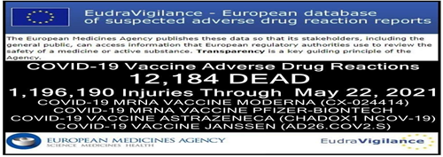

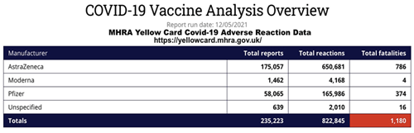

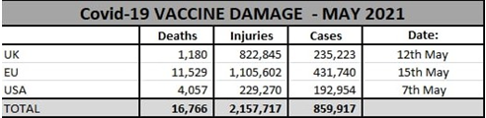

You are Accountable
You are a principal and a source of authority in relation to the SARS-CoV-2 response measures in England in your current position of responsibility in this position you have accepted, including if you have taken an Oath to uphold the Constitution. On your shoulders rests the responsibility of the SARS-CoV-2 measures in Éire and you are accountable in your private and public capacity for your actions and omissions, the accountability and responsibility is applicable to you and to all following and adhering to your instruction.

Nuremberg Code

For evil to succeed, it is enough for good men (and women) to do nothing

You are named here as a Respondent because of your current role. Under the Nuremberg Code (1947) and its 10 basic principles (Exhibit 1), ‘it is a personal duty and responsibility’ to ensure that measures taken, including the experimental clinical trials being carried out in England, involving men and women, meet all the requirements of the Nuremberg Code, most importantly they are safe and necessary.

Further References:
As jabs do not make you immune or stop the spread, the government speaking of domestic vaccine passports is seeking to commit Medical Apartheid without premise.
It is also coercion to remove freewill and if allowed full implementation of a dictatorship.
Guidelines are not laws and have not been passed in parliament and as such cannot be lawfully enforced.
Guide lines are in breach of our fundamental inalienable rights as a species. Any officer enforcing guidelines is acting unlawfully and trespassing against his fellow man.
Your own due diligence is required.
Your prior ignorance regarding the deceits required to sustain and participate in these “crimes against humanity” have been negated.
You are now fully aware of false narrative and party to the plans of a rogue government.
It is not my intention to harass, intimidate, offend, conspire, blackmail, coerce or cause anxiety, alarm or distress. This Notice of Liability and the enclosed information are presented with honorable and peaceful intentions and are expressly for your benefit to provide you with due process, due diligence and an opportunity to remedy this most serious matter and claim.

Maxim of Law External Actions Show Secret Intentions
Maxim of Law Politics are to be adapted to the laws not the law to politics
Maxim of law A traitor is punished so one and not all may perish

Served by ____________________

on this___ day of the ________ month in the year of our Lord, Two Thousand and Twenty-One.

Without ill will, vexation or frivolity
With sincerity and honour,

___________________________________________________
Autograph

Second Witness, on this ___________ day of the ________ month in the year of our Lord, Two Thousand and Twenty One

___________________________________________________
Autograph

All Rights Reserved.

Served by ____________________

on this___ day of the ________ month in the year of our Lord, Two Thousand and Twenty-One.

Without ill will, vexation or frivolity
With sincerity and honour,

___________________________________________________
Autograph

Second Witness, on this ___________ day of the ________ month in the year of our Lord, Two Thousand and Twenty-One

___________________________________________________
Autograph

All Rights Reserved

https://www.gov.uk/guidance/high-consequence-infectious-diseases-hcid

Copied from the Government website

Status of COVID-19

As of 19 March 2020, COVID-19 is no longer considered to be a high consequence infectious disease (HCID) in the UK. There are many diseases which can cause serious illness which are not classified as HCIDs.
The 4 nations public health HCID group made an interim recommendation in January 2020 to classify COVID-19 as an HCID. This was based on consideration of the UK HCID criteria about the virus and the disease with information available during the early stages of the outbreak. Now that more is known about COVID-19, the public health bodies in the UK have reviewed the most up to date information about COVID-19 against the UK HCID criteria. They have determined that several features have now changed; in particular, more information is available about mortality rates (low overall), and there is now greater clinical awareness and a specific and sensitive laboratory test, the availability of which continues to increase.
The Advisory Committee on Dangerous Pathogens (ACDP) is also of the opinion that COVID-19 should no longer be classified as an HCID.
The World Health Organization (WHO) continues to consider COVID-19 as a Public Health Emergency of International Concern (PHEIC), therefore the need to have a national, coordinated response remains and this is being met by the government’s COVID-19 response.
Cases of COVID-19 are no longer managed by HCID treatment centres only. All healthcare workers managing possible and confirmed cases should follow the updated national infection and prevention (IPC) guidance for COVID-19, which supersedes all previous IPC guidance for COVID-19. This guidance includes instructions about different personal protective equipment (PPE) ensembles that are appropriate for different clinical scenarios.

https://www.meity.gov.in/writereaddata/files/MeitY_advisory_to_Social_Media_on_Corona_07May2021.pdf

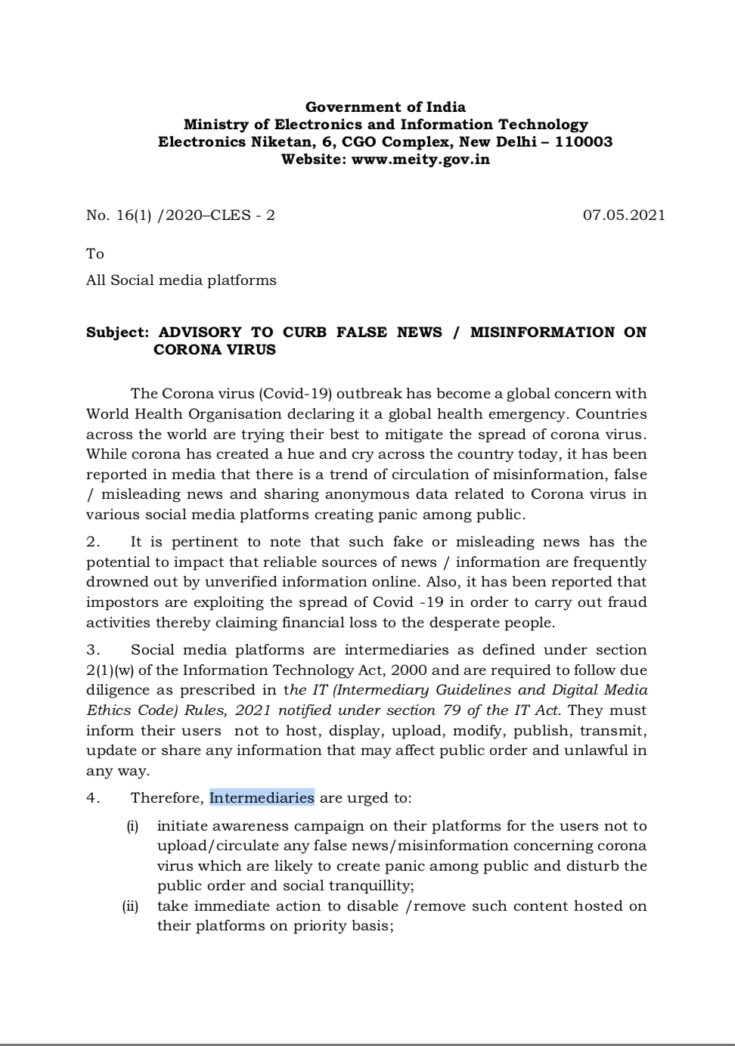
https://www.meity.gov.in/writereaddata/files/MeitY_advisory_to_Social_Media_on_Corona_07May2021.pdf
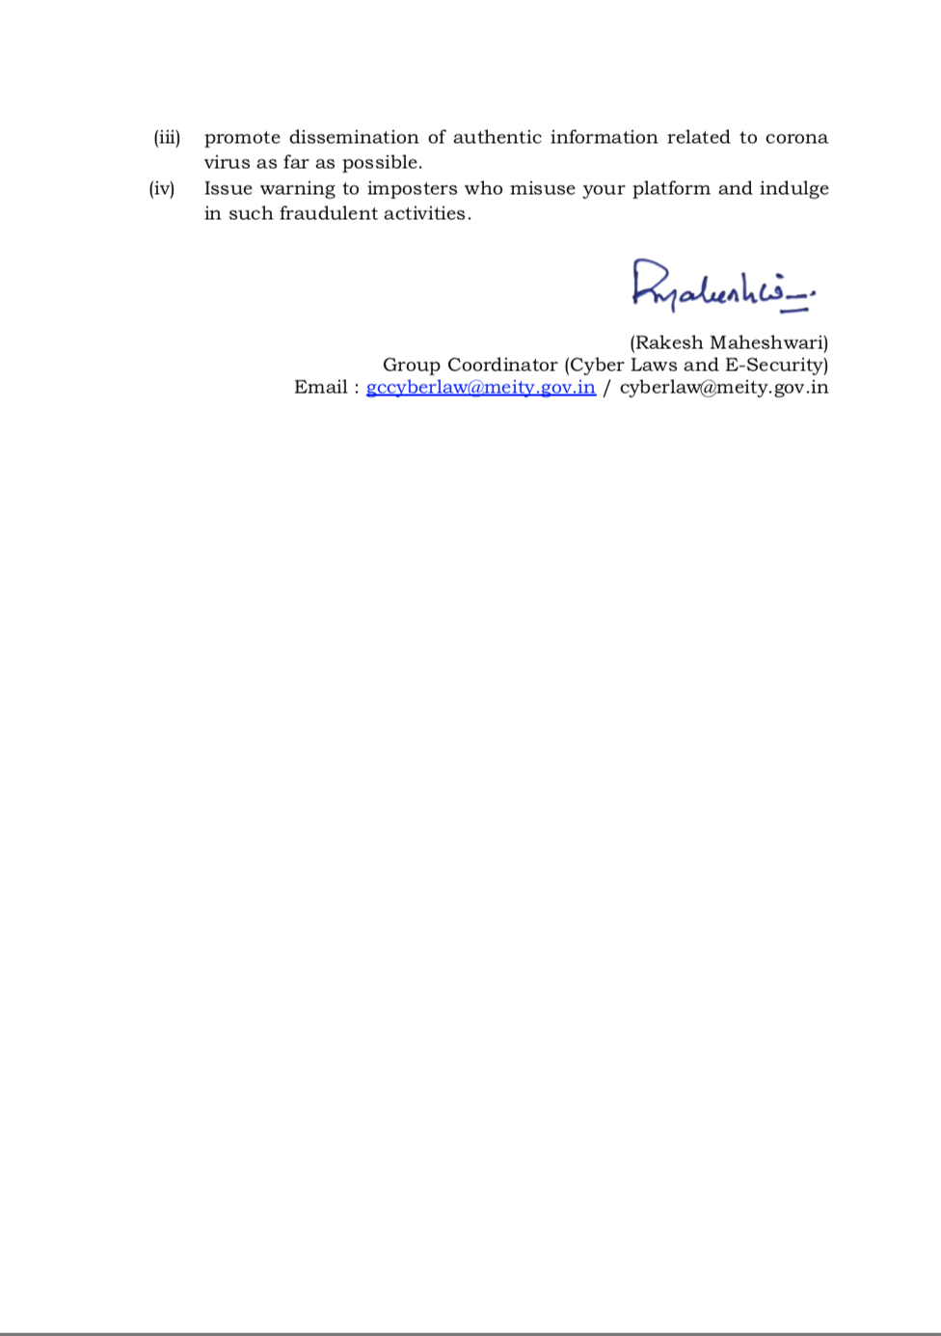
https://assets.publishing.service.gov.uk/government/uploads/system/uploads/attachment_data/file/975909/S1182_SPI-M-O_Summary_of_modelling_of_easing_roadmap_step_2_restrictions.pdf

Who becomes seriously ill in a resurgence?
55. Figure 11 illustrates the age and vaccination status of those hospitalised (left) and dying (right) over time in Warwick’s central scenario for the whole roadmap (equivalent to Figure 4). The top plots are absolute numbers and the bottom plots are as a proportion of those admitted or dying.

56. This shows that most deaths and admissions in a post-Roadmap resurgence are in people who have received two vaccine doses, even without vaccine protection waning or a variant emerging that escapes vaccines. This is because vaccine uptake has been so high in the oldest age groups (modelled here at 95% in the over 50-year olds). There are therefore 5% of over 50-year olds who have not been vaccinated, and 95% x 10% = 9.5% of over 50-year olds who are vaccinated but, nevertheless, not protected against death. This is not the result of vaccines being ineffective, merely uptake being so high.
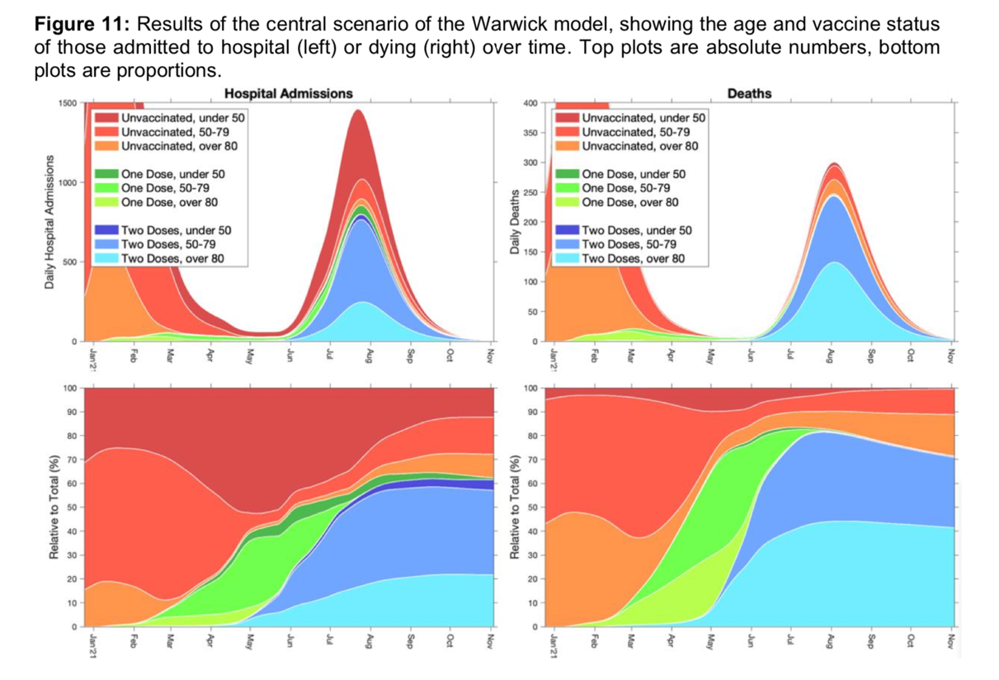
Implications of uneven vaccine coverage
57.These models do not account for vaccination coverage being different in different communities. Early evidence suggests that coverage has, so far, been lower in some minority ethnic groups. As a result, even if vaccination successfully drives down mortality and morbidity overall, it is highly likely that outbreaks will still happen in some communities.
18 of 23

https://post.parliament.uk/covid-19-vaccines-november-update-progress-of-clinical-trials/

A successful COVID-19 vaccine, complementing other non-pharmaceutical interventions aiming to reduce the spread of SARS-CoV-2, has the potential to eradicate the disease. Immunising the whole population, vulnerable groups or people most likely to transmit the virus is considered by many to be the most important and effective intervention. Immunisation could suppress the transmission of the virus, reduce the incidence of illness and mortality, and allow the lifting of restrictions on daily life. At present it is unknown whether there will be a successful COVID-19 vaccine and whether it will be able to provide complete protection from SARS-CoV-2 infection.
Development of COVID-19 vaccines started as soon as the sequence of SARS-CoV-2 was identified and is progressing at unprecedented speed. The completion of some clinical trials is expected by the end of 2020. The UK has pledged £250m to the Coalition for Epidemic Preparedness Innovations (CEPI) for the development of a SARS-CoV-2 vaccine and has changed regulations to allow a COVID-19 vaccine to be fast-tracked.
As of 3 November 2020, the latest World Health Organization figures show over 200 vaccines in development, 47 of which are being tested in people.

There are currently 11 vaccine candidates being tested in large Phase III clinical trials. A recent review published in the Lancet describes them in more detail. The table below summarises Phase III trials for different candidates, indicating the expected completion date. The candidates for which the UK has secured early access are indicated with an asterisk.

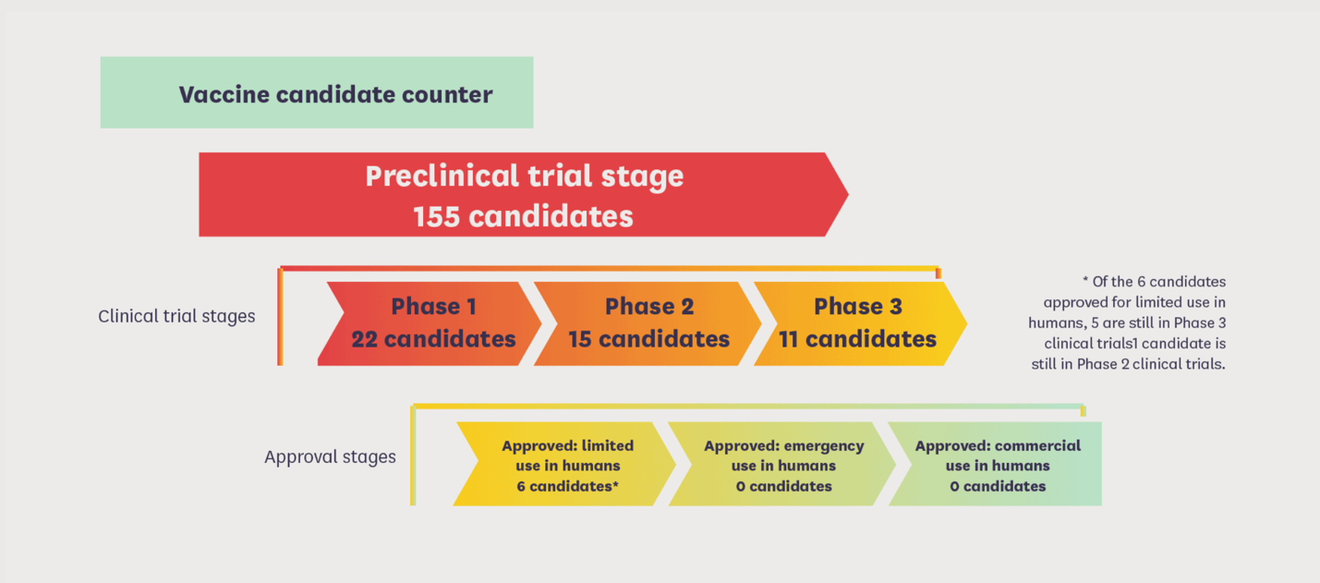
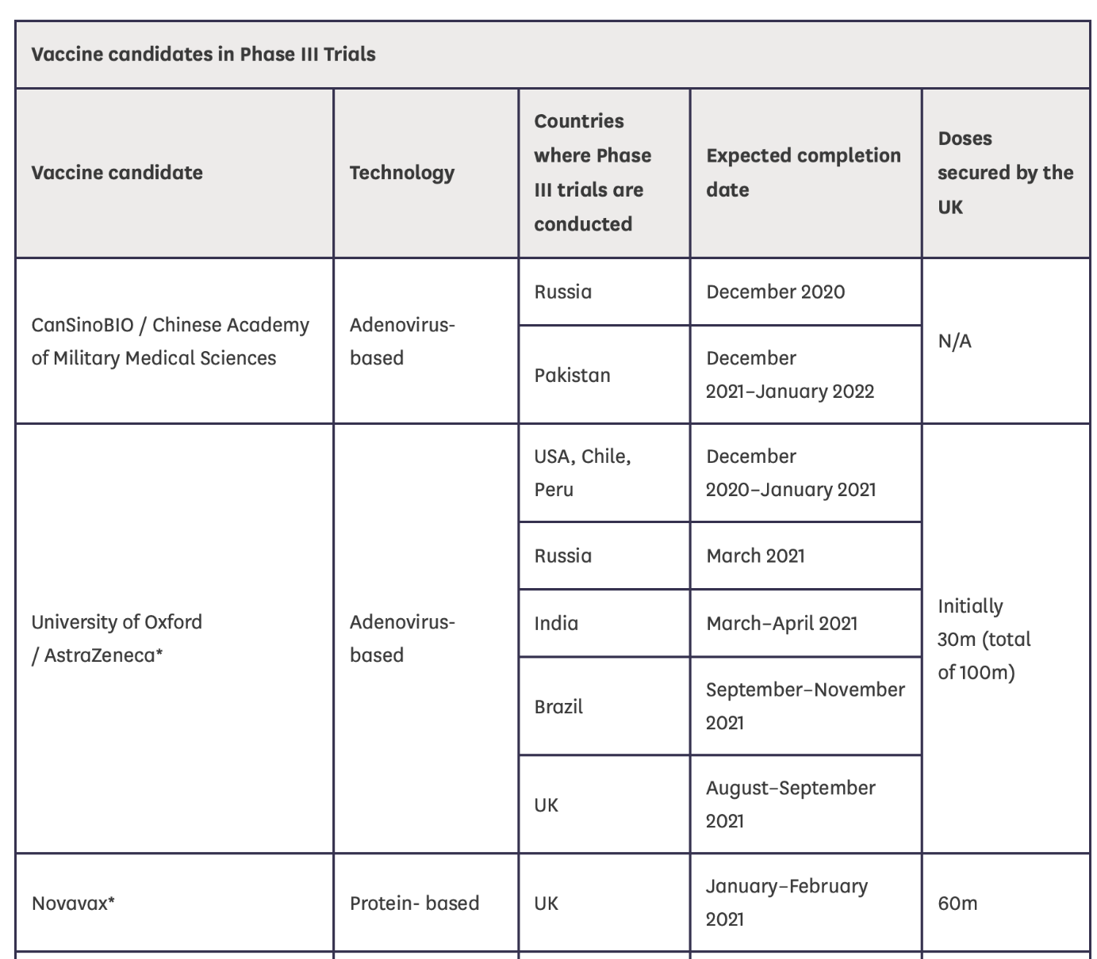

*AstraZeneca trial expected completion Aug-Sept 2021

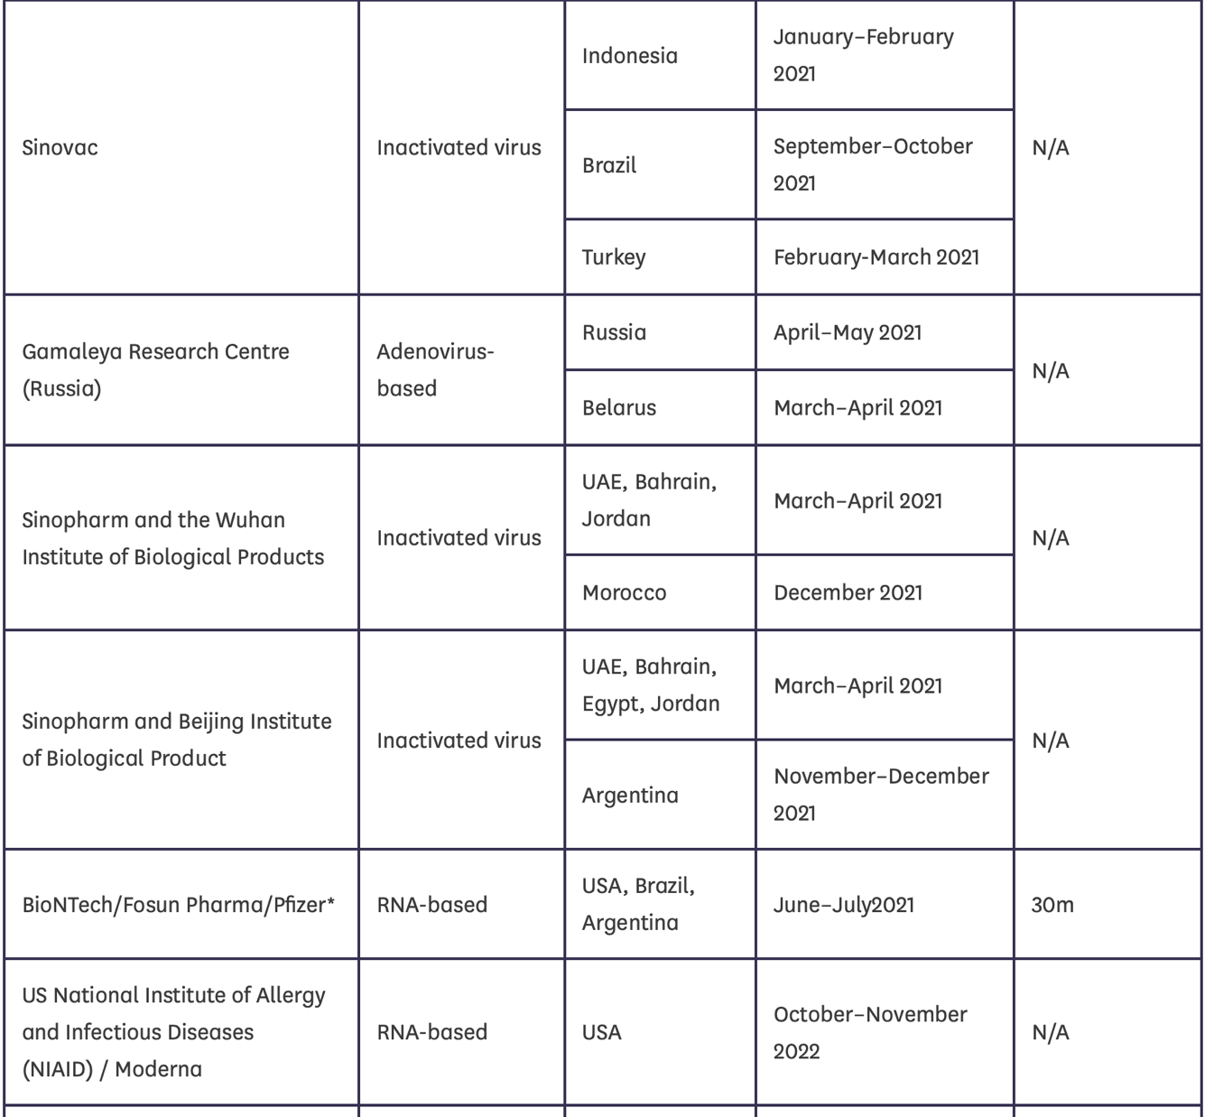

*Pfizer trial expected completion June-July 2021
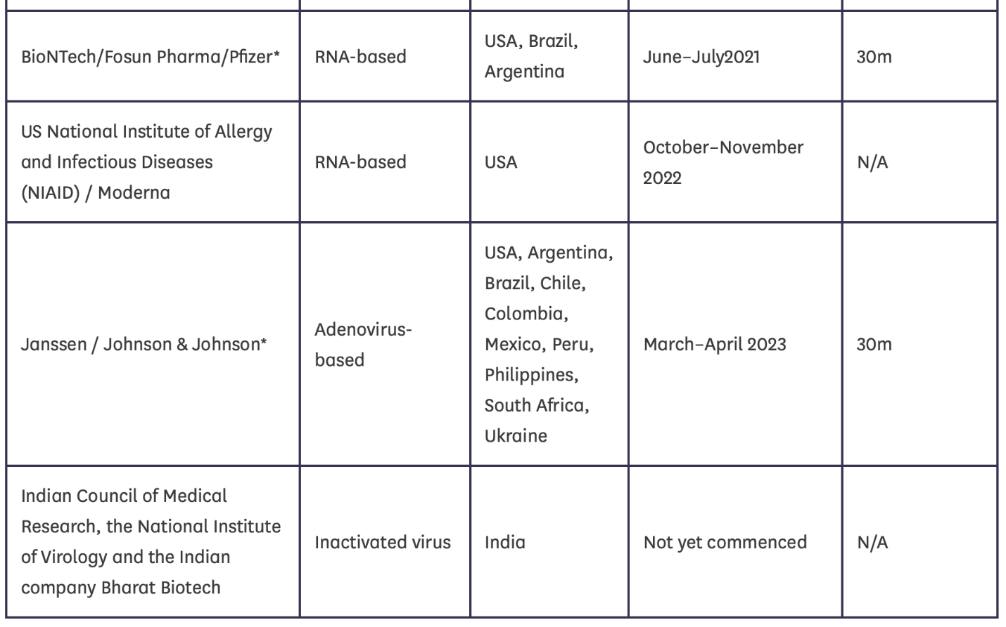
*Johnson & Johnson (UK have early access to) expected trial completion March – April 2023

https://www.ema.europa.eu/en/documents/product-information/covid-19-vaccine-astrazeneca-product-information-approved-chmp-29-january-2021-pending-endorsement_en.pdf
COVID-19 Vaccine AstraZeneca Patient Information
[Page 3]
- QUALITATIVE AND QUANTITATIVE COMPOSITION
These are multidose vials which contain 8 doses or 10 doses of 0.5 ml per vial (see section 6.5).
One dose (0.5 ml) contains:
Chimpanzee Adenovirus encoding the SARS-CoV-2 Spike glycoprotein (ChAdOx1-S)*, not less than 2.5 × 10⁸ infectious units (Inf.U)
* Produced in genetically modified human embryonic kidney (HEK) 293 cells and by recombinant DNA technology.
This product contains genetically modified organisms (GMOs).

[Page 4]
Paediatric population
The safety and efficacy of COVID-19 Vaccine AstraZeneca in children and adolescents (less than 18 years of age) have not yet been established. No data are available.

[Page 5]
Immunocompromised individuals
The efficacy, safety and immunogenicity of the vaccine have not been assessed in immunocompromised individuals, including those receiving immunosuppressant therapy. The efficacy of COVID-19 Vaccine AstraZeneca may be lower in immunosuppressed individuals.
Duration of protection
The duration of protection afforded by the vaccine is unknown as it is still being determined by ongoing clinical trials.
Limitations of vaccine effectiveness
Protection starts from approximately 3 weeks after the first dose of COVID-19 Vaccine AstraZeneca. Individuals may not be fully protected until 15 days after the second dose is administered. As with all vaccines, vaccination with COVID-19 Vaccine AstraZeneca may not protect all vaccine recipients (see section 5.1).
Currently available clinical trial data do not allow an estimate of vaccine efficacy in subjects over 55 years of age.

4.5 Interaction with other medicinal products and other forms of interaction
No interaction studies have been performed.
Concomitant administration of COVID-19 Vaccine AstraZeneca with other vaccines has not been studied.
4.6 Fertility, pregnancy and lactation
Pregnancy
There is limited experience with use of COVID-19 Vaccine AstraZeneca in pregnant women.
Animal reproductive toxicity studies have not been completed. Based upon results from the preliminary study, no effects are expected on development of the fetus (see section 5.3).
Administration of COVID-19 Vaccine AstraZeneca during pregnancy should only be considered when the potential benefits outweigh any potential risks for the mother and fetus.
Breastfeeding
It is unknown whether COVID-19 Vaccine AstraZeneca is excreted in human milk.

[Page 9]
5.3 Preclinical safety data
Non-clinical data reveal no special hazard for humans based on a conventional study of repeat dose toxicity.
Genotoxicity/Carcinogenicity
Neither genotoxicity nor carcinogenicity studies were performed. The components of the vaccine are not expected to have genotoxic potential.
Reproductive toxicity
Animal studies of potential toxicity to reproduction and development have not yet been completed. A preliminary reproductive toxicity study in mice does not show toxicity in dams or foetuses.

http://labeling.pfizer.com/ShowLabeling.aspx?id=14472

COVID-19 PFIZER BIONTECH VACCINE SAFETY DATA SHEET
[page 1]
The Pfizer-BioNTech COVID-19 Vaccine is a vaccine and may prevent you from getting COVID-19. There is no U.S. Food and Drug Administration (FDA) approved vaccine to prevent COVID-19.
The Pfizer-BioNTech COVID-19 Vaccine may not protect everyone.
WHAT IS THE PFIZER-BIONTECH COVID-19 VACCINE?
The Pfizer-BioNTech COVID-19 Vaccine is an unapproved vaccine that may prevent COVID-19. There is no FDA-approved vaccine to prevent COVID-19.

[page 2]
The FDA has authorized the emergency use of the Pfizer-BioNTech COVID-19 Vaccine to prevent COVID-19 in individuals 12 years of age and older under an Emergency Use Authorization (EUA).

[page 3]
HAS THE PFIZER-BIONTECH COVID-19 VACCINE BEEN USED BEFORE?
The Pfizer-BioNTech COVID-19 Vaccine is an unapproved vaccine. In clinical trials, approximately 23,000 individuals 12 years of age and older have received at least
1 dose of the Pfizer-BioNTech COVID-19 Vaccine.

[page 3]
Side effects that have been reported with the Pfizer-BioNTech COVID-19 Vaccine include:
• severe allergic reactions
• non-severe allergic reactions such as rash, itching, hives, or swelling of the face
• injection site pain
• tiredness
• headache
• muscle pain
• chills
• joint pain
• fever
• injection site swelling
• injection site redness
• nausea
• feeling unwell
• swollen lymph nodes (lymphadenopathy)
• diarrhea
• vomiting
• arm pain
These may not be all the possible side effects of the Pfizer-BioNTech COVID-19 Vaccine. Serious and unexpected side effects may occur. Pfizer-BioNTech COVID-19 Vaccine is still being studied in clinical trials.

[page 4]
WHAT IF I DECIDE NOT TO GET THE PFIZER-BIONTECH COVID-19 VACCINE?
It is your choice to receive or not receive the Pfizer-BioNTech COVID-19 Vaccine. Should you decide not to receive it, it will not change your standard medical care.

ARE OTHER CHOICES AVAILABLE FOR PREVENTING COVID-19 BESIDES PFIZER-BIONTECH COVID-19 VACCINE?
Currently, there is no approved alternative vaccine available for prevention of COVID-19. Other vaccines to prevent COVID-19 may be available under Emergency Use Authorization.

WHAT IS AN EMERGENCY USE AUTHORIZATION (EUA)?
The United States FDA has made the Pfizer-BioNTech COVID-19 Vaccine available under an emergency access mechanism called an EUA. The EUA is supported by a Secretary of Health and Human Services (HHS) declaration that circumstances exist to justify the emergency use of drugs and biological products during the COVID-19 pandemic.
The Pfizer-BioNTech COVID-19 Vaccine has not undergone the same type of review as an FDA-approved or cleared product. FDA may issue an EUA when certain criteria are met, which includes that there are no adequate, approved, available alternatives. In addition, the FDA decision is based on the totality of scientific evidence available showing that the product may be effective to prevent COVID-19 during the COVID-19 pandemic and that the known and potential benefits of the product outweigh the known and potential risks of the product. All of these criteria must be met to allow for the product to be used in the treatment of patients during the COVID-19 pandemic.
The EUA for the Pfizer-BioNTech COVID-19 Vaccine is in effect for the duration of the COVID-19 EUA declaration justifying emergency use of these products, unless terminated or revoked (after which the products may no longer be used).

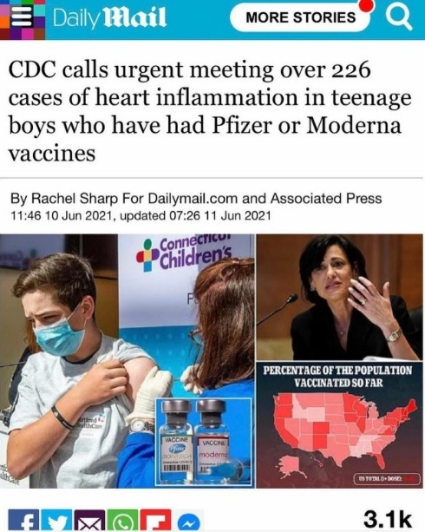

[Page 85]
Please see full 85 pages of reactions from Pfizer vaccine being offered to 12 year olds.
https://assets.publishing.service.gov.uk/government/uploads/system/uploads/attachment_data/file/992564/COVID-19_mRNA_Pfizer-BioNTech_Vaccine_Analysis_Print_-_DLP_02.06.2021.pdf

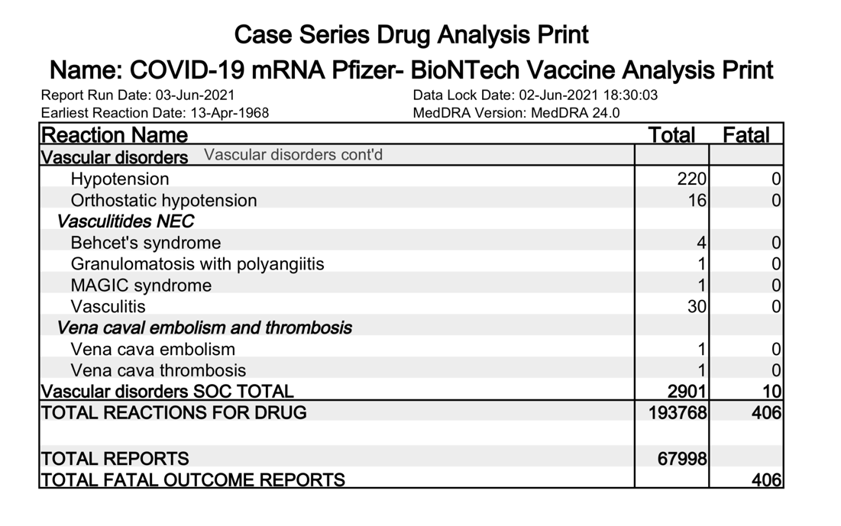

https://www.sciencedirect.com/science/article/pii/S1201971221003647
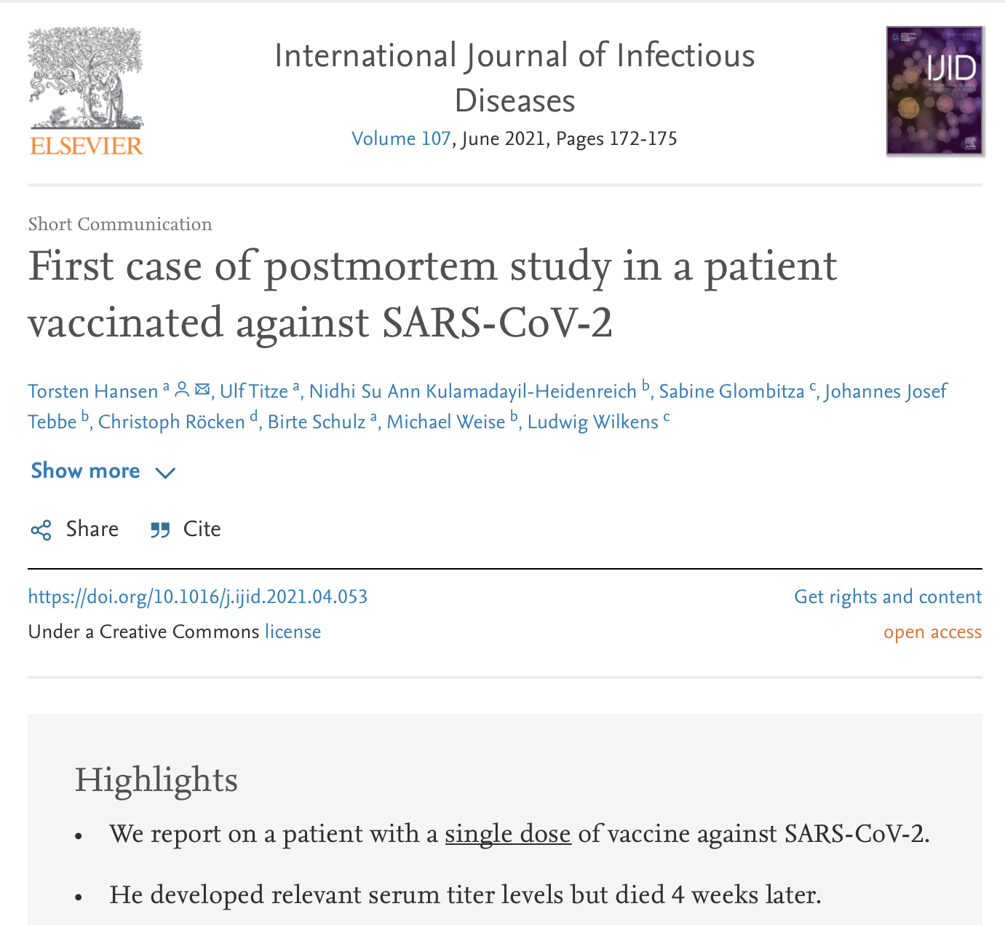
A previously symptomless 86-year-old man received the first dose of the BNT162b2 mRNA COVID-19 vaccine. He died 4 weeks later from acute renal and respiratory failure. Although he did not present with any COVID-19-specific symptoms, he tested positive for SARS-CoV-2 before he died. Spike protein (S1) antigen-binding showed significant levels for immunoglobulin (Ig) G, while nucleocapsid IgG/IgM was not elicited. Acute bronchopneumonia and tubular failure were assigned as the cause of death at autopsy; however, we did not observe any characteristic morphological features of COVID-19. Postmortem molecular mapping by real-time polymerase chain reaction revealed relevant SARS-CoV-2 cycle threshold values in all organs examined (oropharynx, olfactory mucosa, trachea, lungs, heart, kidney and cerebrum) except for the liver and olfactory bulb. These results might suggest that the first vaccination induces immunogenicity but not sterile immunity.

PFIZER DRUG RECALLS AND LAWSUITS
https://www.drugwatch.com/manufacturers/pfizer/

Drug Recalls
Pfizer has had to recall some of its popular products due to quality issues and poor packaging. Effexor XR and Prempro are two products affected by recalls. More recently, the company recalled two lots each of Relpax in 2019 and Duavive in 2020.

Effexor XR
In 2014, Pfizer recalled two lots of its antidepressant drug Effexor XR. Tikosyn was discovered in an Effexor XR bottle. Tikosyn is one of the company’s heart pills. Pfizer warned that the combination of the two different drugs could be deadly.

Prempro
In 2013, Pfizer announced it was recalling five lots of Prempro. Prempro is a hormone replacement therapy drug. Routine testing revealed the strength of the drug was low.

Lawsuits and Settlements
Over the years, Pfizer has faced lawsuits involving some of its most popular drugs. Courts have dismissed thousands of lawsuits against Pfizer. The company has also agreed to settle cases involving claims of illegal marketing and health care fraud.
PFIZER SETTLEMENT AND FINE
Pfizer set a record for the largest health care fraud settlement and the largest criminal fine of any kind with $2.3 billion in 2009.
Source: U.S. Department of Justice

Protonix
People are suing Pfizer over Protonix. Protonix lawsuits say Pfizer failed to warn about the risk of kidney problems. In 2013, Pfizer agreed to pay $55 million to settle criminal charges. The U.S. Department of Justice said Wyeth promoted Protonix for unapproved uses in 2000 and 2001. Pfizer acquired Wyeth in 2009.

Prempro
Nearly 10,000 women filed Prempro breast cancer lawsuits against Pfizer. By 2012, Pfizer settled most of the claims for more than $1 billion.

Chantix
About 3,000 people filed Chantix lawsuits against Pfizer. They claimed Chantix caused suicidal thoughts and severe psychological disorders. In 2013, the company set aside about $288 million to resolve these cases. One case settled for an undisclosed amount just before trial in 2012.

Depo-Testosterone
More than 7,800 testosterone therapy lawsuits had been filed against manufacturers as of November 2020. Pfizer had reached an agreement with the consumers suing the company in February 2018, ending its role in the massive litigation. The lawsuits say testosterone products caused strokes, blood clots and heart attacks.

Effexor
A federal panel closed the consolidated Effexor litigation in 2013. Lawsuits claimed birth defects.

Zoloft
A judge dismissed Zoloft cases in 2016. Lawsuits included similar claims to Effexor XR. The judge did not disagree that Zoloft caused birth defects. But the judge concluded there was insufficient evidence to definitively link the two.

Eliquis
A judge dismissed a group of federal Eliquis cases in 2017. Injured patients continue to file severe bleeding claims in Delaware state court.

Lipitor
A judge dismissed Lipitor lawsuits in 2017. Women who took the drug filed lawsuits after developing Type 2 diabetes. There is currently an appeal pending.

Trovan
In 1996, Pfizer conducted an unapproved clinical trial. It involved children with meningitis in Nigeria, CBS News reported. The trials led to the deaths of 11 children. Dozens more were left disabled.

PFIZER’S UNAPPROVED CLINICAL TRIAL
The unauthorized trial involved tests on 200 children with Pfizer's antibiotic Trovan.
Source: BBC News
Trovan is a drug severely restricted in use because of its potential to cause liver damage. Injury to the liver as a result of taking Trovan can lead to liver failure and death.
In 2011, Pfizer paid $700,000 to four families who lost children during the Trovan trials.
In addition, the company set up a $35 million fund for those affected by Trovan. Pfizer also agreed to sponsor health projects in Kano, Nigeria.

Newsround Claims shown to our children in PRIMARY SCHOOL

https://www.youtube.com/watch?v=I3uq2FeqFRA

- They said “In the U.S in 12 to 15 year old's there were absolutely no cases of illness, so it looks like the vaccine does protect from covid 19”.

- “Having the vaccine is a small price to pay for being protected from the virus WHEN it comes”.

- “The benefit of getting a vaccine is that you don’t need to worry about Covid-19 it means you’re likely not to be able to infect your parents, the people you live with and your teachers.

- “The downside – it’s another jab, another injection into your arm, but the benefits DEFINATLEY outweigh the risk”.

- ”There are trials ongoing to try to change the age groups to make it more appropriate”.

In regards to the above information being shown to children, please see the definitions of the below words as these behaviours are being used towards our children and the rest of the British public.
‘Fundamental British values’ is taken from the definition of extremism as articulated in the new Prevent Strategy, which was launched in June 2011. It includes ‘democracy, the rule of law, individual liberty and mutual respect and tolerance of different faiths and beliefs’.
Please see The Children Act 1989 subsection 22 “General duty of a local authority in relation to children looked after by them.”
(4)Before making any decision with respect to a child whom they are looking after, or proposing to look after, a local authority shall, so far as is reasonably practicable, ascertain the wishes and feelings of—
(a)the child;
(b)his parents;
(c)any person who is not a parent of his but who has parental responsibility for him; and
(d)any other person whose wishes and feelings the authority consider to be relevant,
regarding the matter to be decided.

Definition of coercion
The practice of persuading someone to do something by using force or threats.
Definition of emotional manipulation
Emotional manipulation occurs when a manipulative person seeks power over someone else and employs dishonest or exploitive strategies to gain it. Unlike people in healthy relationships, which demonstrate reciprocity and cooperation, an emotional manipulator looks to use, control, or even victimize someone else.
Indoctrination
The process of teaching a person or group to accept a set of beliefs uncritically.
Definition of terrorism
The unlawful use of violence and intimidation, especially against civilians, in the pursuit of political aims.

Human Rights Act 1998
Article 3: Freedom from torture and inhuman or degrading treatment:
Inhuman treatment or punishment is treatment which causes intense physical or mental suffering. It includes:
- serious physical assault
- psychological interrogation
- cruel or barbaric detention conditions or restraints
- serious physical or psychological abuse in a health or care setting, and
- threatening to torture someone, if the threat is real and immediate.

What is degrading treatment?
Degrading treatment means treatment that is extremely humiliating and undignified. Whether treatment reaches a level that can be defined as degrading depends on a number of factors. These include the duration of the treatment, its physical or mental effects and the sex, age, vulnerability and health of the victim. This concept is based on the principle of dignity - the innate value of all human beings.

Ethylene Oxide Substance Explained
https://www.cancer.gov/about-cancer/causes-prevention/risk/substances/ethylene-oxide

Ethylene Oxide
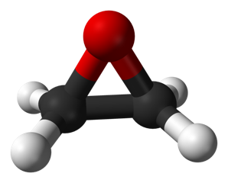
A model of the ethylene oxide molecule.

What is ethylene oxide?
At room temperature, ethylene oxide is a flammable colorless gas with a sweet odor. It is used primarily to produce other chemicals, including antifreeze. In smaller amounts, ethylene oxide is used as a pesticide and a sterilizing agent. The ability of ethylene oxide to damage DNA makes it an effective sterilizing agent but also accounts for its cancer-causing activity.

How are people exposed to ethylene oxide?
The primary routes of human exposure to ethylene oxide are inhalation and ingestion, which may occur through occupational, consumer, or environmental exposure. Because ethylene oxide is highly explosive and reactive, the equipment used for its processing generally consists of tightly closed and highly automated systems, which decreases the risk of occupational exposure.
Despite these precautions, workers and people who live near industrial facilities that produce or use ethylene oxide may be exposed to ethylene oxide through uncontrolled industrial emissions. The general population may also be exposed through tobacco smoke and the use of products that have been sterilized with ethylene oxide, such as medical products, cosmetics, and beekeeping equipment.

Which cancers are associated with exposure to ethylene oxide?
Lymphoma and leukemia are the cancers most frequently reported to be associated with occupational exposure to ethylene oxide. Stomach and breast cancers may also be associated with ethylene oxide exposure.

How can exposures be reduced?
The U.S. Occupational Safety and Health Administration has information about limiting occupational exposure to ethylene oxide.

Selected References:
- Health Effects Notebook for Hazardous Air Pollutants: Ethylene Oxide. Washington, DC: U.S. Environmental Protection Agency, 2018. Also available online. Last accessed December 28, 2018.
- International Agency for Research on Cancer. Ethylene Oxide, IARC Monographs on the Evaluation of Carcinogenic Risks to Humans, Volume 100F. Lyon, France: World Health Organization, 2012. Also available onlineExit Disclaimer. Last accessed December 28, 2018.
- National Toxicology Program. Ethylene Oxide, Report on Carcinogens, Fourteenth Edition. Triangle Park, NC: National Institute of Environmental Health and Safety, 2016. Also available online. Last accessed December 28, 2018.

Sterilising agent used in disposable surgical facemasks
https://www.sciquip.co.uk/disposable-medical-face-masks.html
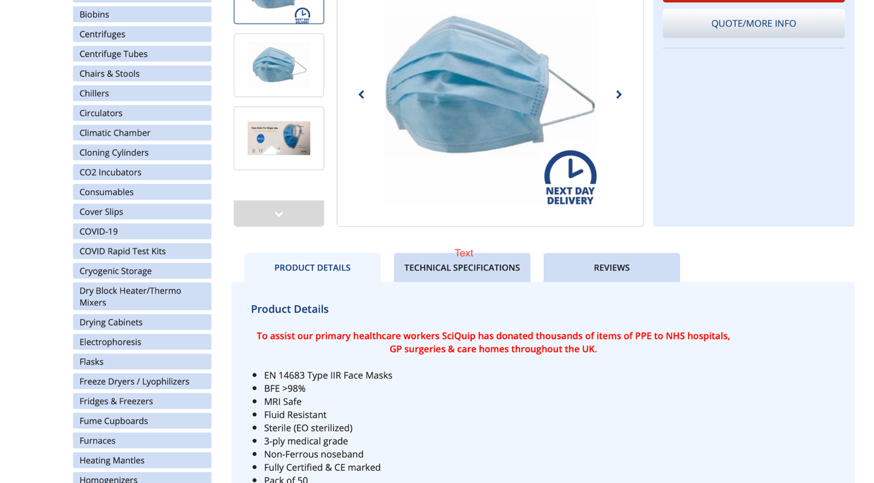
Please see in product details: Sterile (EO sterilised)

Covid-19 NHS testing instructions
https://assets.publishing.service.gov.uk/government/uploads/system/uploads/attachment_data/file/957271/COVID-19-self-test-instructions.pdf

[Page 20 – last page]

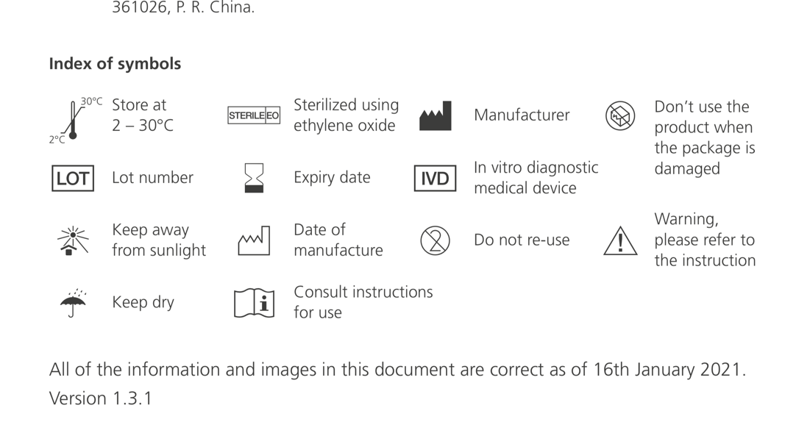

News article related to the dangers of Ethylene Oxide:
https://www.safetyandhealthmagazine.com/articles/19951-extremely-hazardous-alert-warns-against-using-ethylene-oxide-to-sterilize-masks-respirators

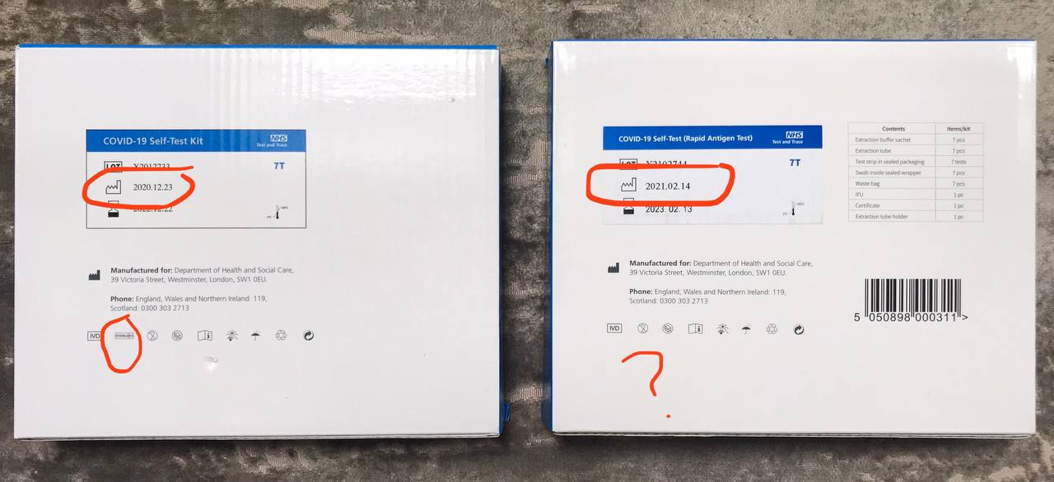

*Please look at manufacturer date and the removal of statement of using EO on the box; it is still on each individual wrapper. It has clearly been removed to conceal vital information from the public regarding their health.

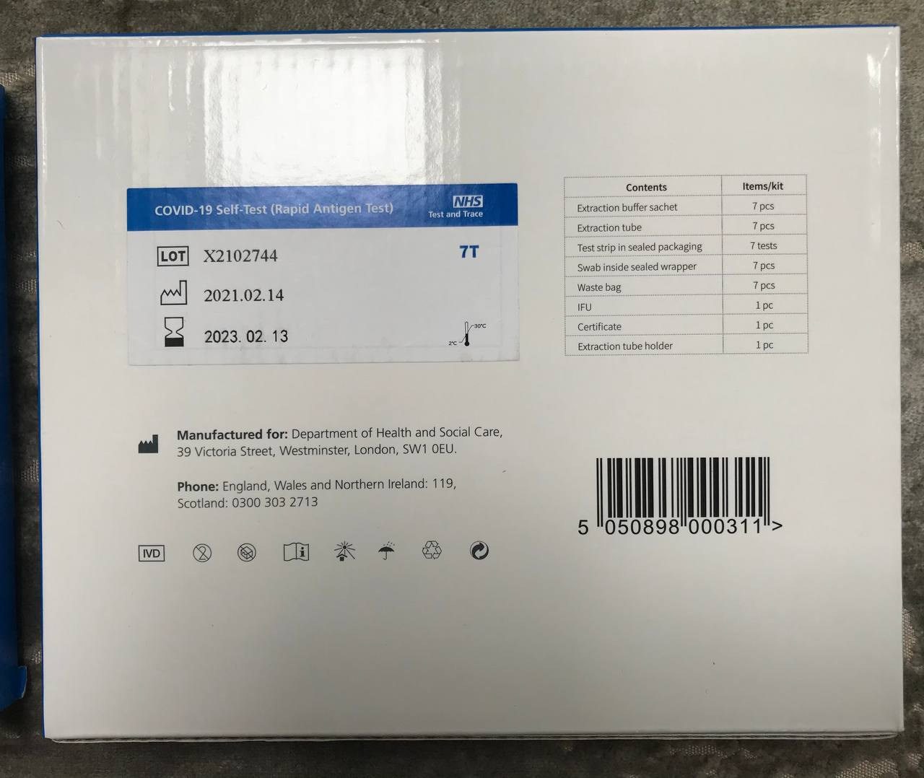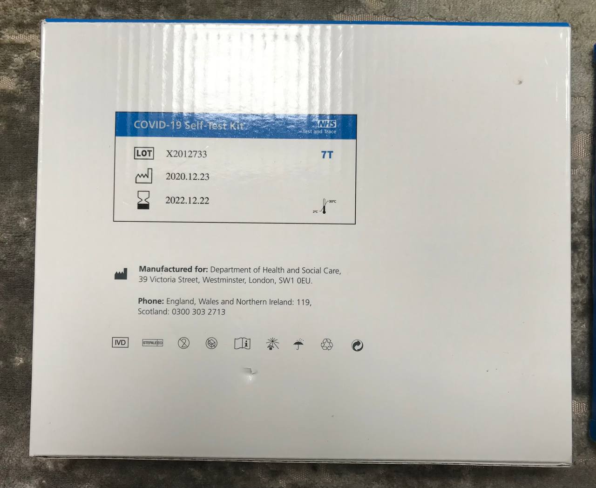
COVID PCR TESTS ARE AS DANGEROUS AS INHALING ASBESTOS
https://dailyexpose.co.uk/2021/05/21/covid-pcr-test-swabs-are-as-dangerous-as-inhaling-asbestos/
An experimental physicist and bio-materials researcher examined various PCR test swabs under a microscope and found that the fibres they contain are as dangerous for human beings as inhaling asbestos.
Professor Antonietta Gatti examined various PCR test swabs and analysed their ingredients. The results showed that they are made of tough materials and contain a large number of nano-particles including silver, aluminum, titanium, and glass fibres. All of which are not declared on the PCR test package insert.
According to the Professor if these fibres get stuck in the mucous membranes they can cause severe wounds and inflammation. Mucous membranes that are no longer intact can no longer fulfill their role of fending off viruses, bacteria and fungi before they reach the airways. The germs penetrate the respiratory tract without any immune filter. This isn’t good news for those who have been compliant with the authorities rules since the start of the alleged pandemic and take part in regular testing and mask wearing. This is because face coverings are the ideal breeding ground for all types of germs.

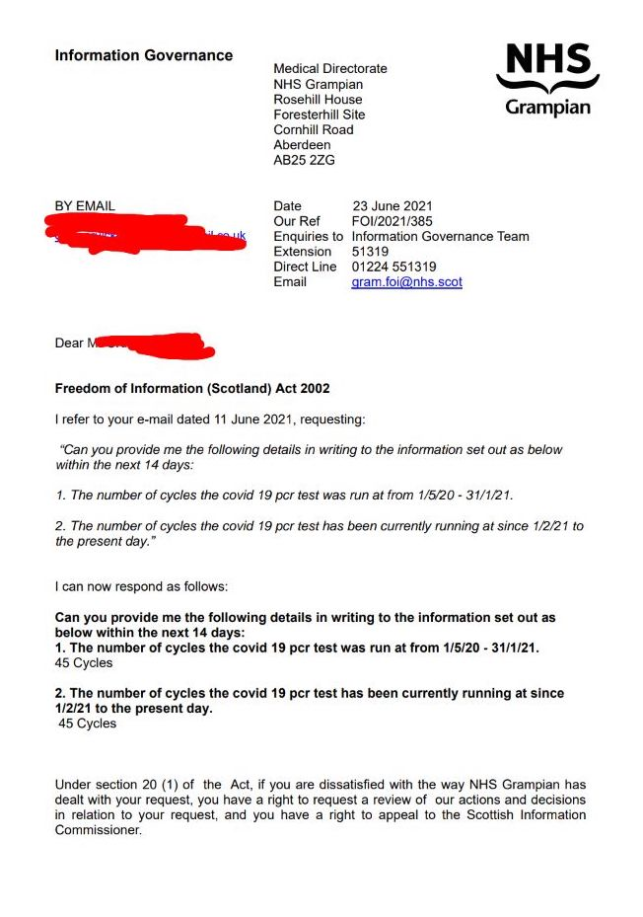
https://clinicaltrials.gov/ct2/show/NCT04651413

Currently, in the United Kingdom, the recommended method for diagnostic testing and screening for COVID-19 is quantitative (real-time) reverse transcription polymerase chain reaction (PCR) analysis of viral RNA extracted from upper respiratory tract samples. A positive result indicates that SARS-CoV-2 RNA has been detected with a cycle threshold (Ct) value of less than 38 cycles of amplification (n.b. this is a locally agreed value, which is based on analysis of proficiency testing performance and other local testing data.

Exemption cards
If you have an age, health or disability reason for not wearing a face covering:
- you do not routinely need to show any written evidence of this
- you do not need show an exemption card
This means that you do not need to seek advice or request a letter from a medical professional about your reason for not wearing a face covering.
However, some people may feel more comfortable showing something that says they do not have to wear a face covering. This could be in the form of an exemption card, badge or even a home-made sign.
Carrying an exemption card or badge is a personal choice and is not required by law.
If you wish to use an exemption card or badge, you can download exemption card templates. You can then print these yourself or show them on a mobile device. Please note that the government is not able to provide physical exemption cards or badges.
https://www.gov.uk/government/publications/face-coverings-when-to-wear-one-and-how-to-make-your-own/face-coverings-when-to-wear-one-and-how-to-make-your-own

Is it discriminatory to challenge a person not wearing a face mask?
The regulations specify that there are only certain people who can direct others to wear or remove face coverings, or deny people entry to relevant places or services because of a lack of face covering. These include police officers and TfL staff.
However the power has limits. There is no legal requirement for people who are exempt to provide proof of their exemption; verbal confirmation should be sufficient. If a customer is wearing an exemption badge or lanyard, there should be no need for staff or police to challenge them at all.
TfL and the police must act in a non-discriminatory manner in line with the Equality Act 2010. Even though they have the power to enforce the face covering regulations, if they inappropriately challenge a disabled person regarding a lack of face covering, become abusive, demand evidence of exemption or impose any other requirement beyond verbal confirmation (such as insisting a person should wear a lanyard) this could amount to discrimination on the grounds of disability.
https://www.hja.net/expert-comments/blog/civil-liberties-human-rights/is-it-ok-to-ask-why-someone-is-not-wearing-a-face-mask/

What is classed as a disability?
In the Equality Act a disability means a physical or a mental condition which has a substantial and long-term impact on your ability to do normal day to day activities.
You are covered by the Equality Act if you have a progressive condition like HIV, cancer or multiple sclerosis, even if you are currently able to carry out normal day to day activities. You are protected as soon as you are diagnosed with a progressive condition.
You are also covered by the Equality Act if you had a disability in the past. For example, if you had a mental health condition in the past which lasted for over 12 months, but you have now recovered, you are still protected from discrimination because of that disability.

https://www.vernoncoleman.com/pdfupdatedmaskbook.pdf
Please use this book for reference with 111 points as to why facemasks are dangerous to health.
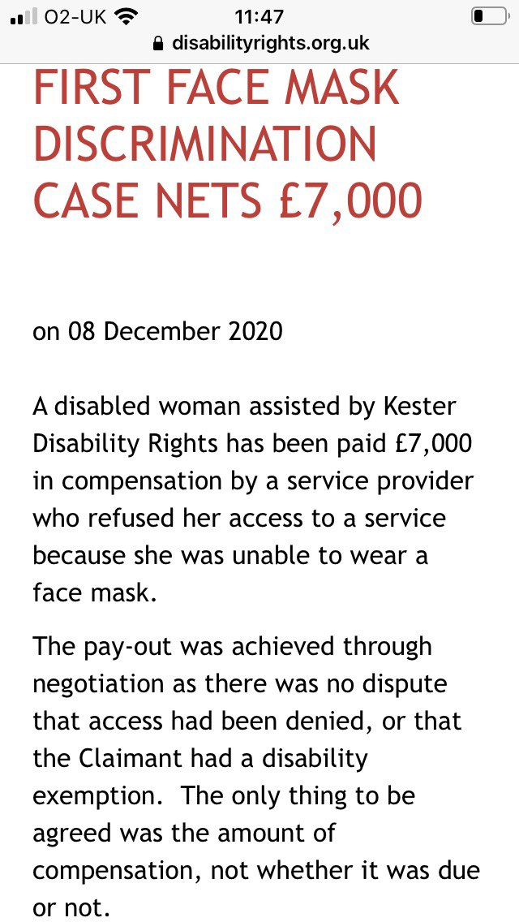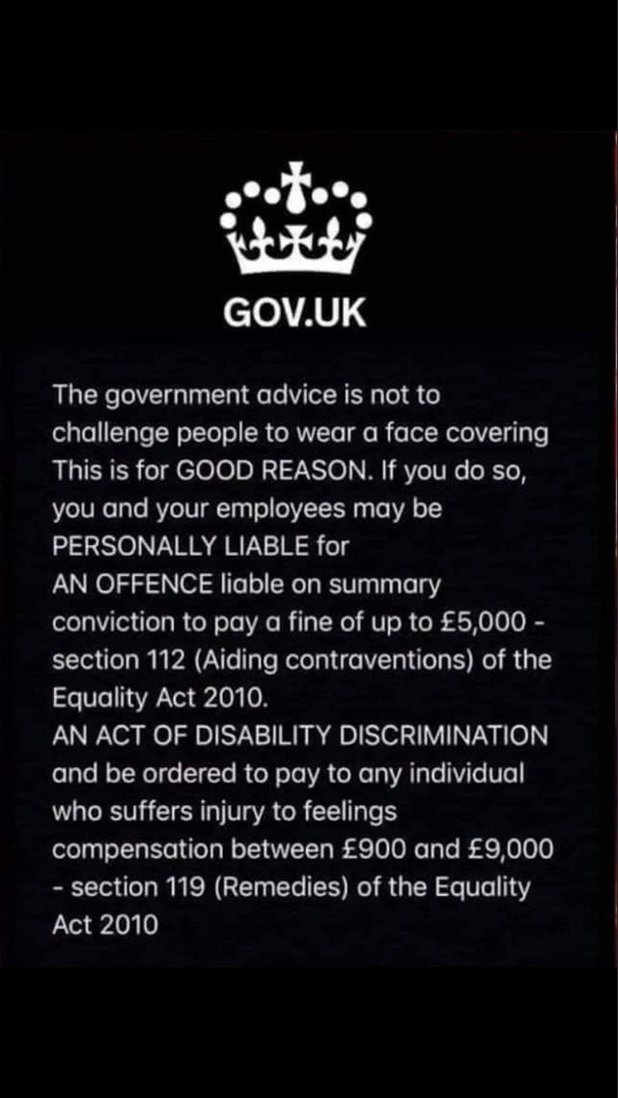|

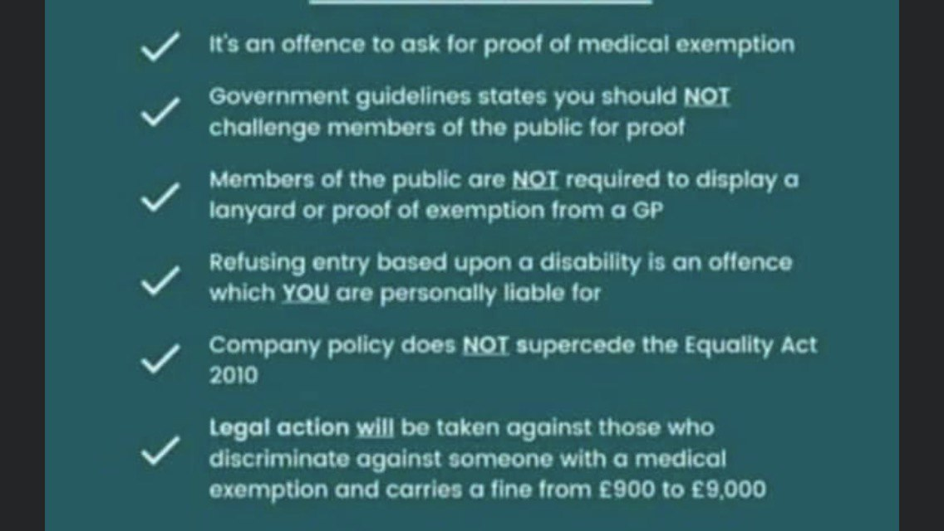

Imperial College London COVID-19 Testing Research Study
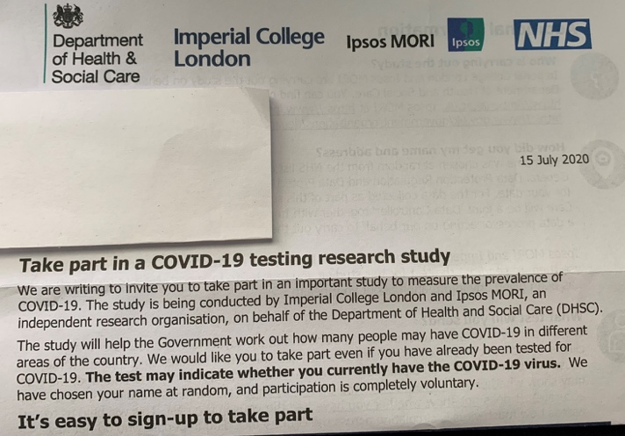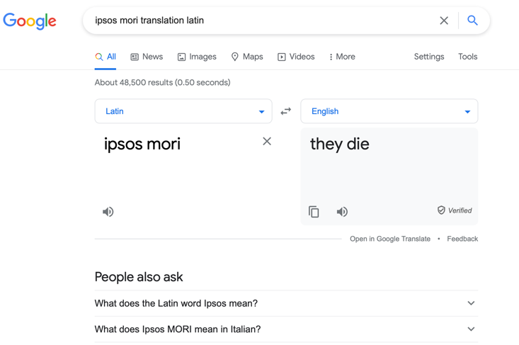

What is the REACT study?
REACT (Real-time Assessment of Community Transmission) is a series of studies that are using home testing to improve our understanding of how the COVID-19 pandemic is progressing across England. This major research programme was commissioned by the Department of Health and Social Care (DHSC) and is being carried out by Imperial College London in partnership with Ipsos MORI and Imperial College Healthcare NHS Trust. Here’s our announcement from when the study first launched in April 2020.

https://www.imperial.ac.uk/medicine/research-and-impact/groups/react-study/
https://www.ipsos.com/ipsos-mori/en-uk/covid-19-swab-test-faqs
ipsos mori translation Latin

Freedom of Information Requests & Further information

Maidstone Borough Council Freedom of Information Act Request Ref: FOI/4645
Date: 14/06/2021
Request and Response
Please can you supply me with a list of burials and cremations during the period of 2015 to 2020 for all of Maidstone Borough and district of KENT.
Please note that we only hold the information for Maidstone Borough, we do not hold information for the whole district of Kent.
Year | Total number of cremations | Total number of burials
2015 | 1,574 | 130
2016 | 1,663 | 107
2017 | 1,618 | 133
2018 | 1,726 | 135
2019 | 1,646 | 127
2020 | 2,009 | 113

https://www.whatdotheyknow.com/request/environmental_information_regula_19#outgoing-1165510

Swale Borough Council
Freedom of Information Act Request Ref: FOI No. 183
Date: 28th May 2021
Request and Response
Please can you supply me with a list of burials and cremations during the period of 2015 to 2020 for all of Swale Borough district of KENT.
Clarified to, all burial and cremation numbers year in year out for the period 2015 to
2020 for all of Swale Borough District of Kent.
Full burials
2015 – 123
2016 – 100
2017 – 105
2018 – 92
2019 – 104
2020 – 110
Note: Our response of numbers for full burials only relates to the cemeteries that Swale Borough Council are responsible for.
Cremated remains
2015 – 80
2016 – 88
2017 – 98
2018 – 88
2019 – 73
2020 – 66
Note: We do not have a Crematorium so our response relates to the burial of cremated remains only.
https://www.whatdotheyknow.com/request/environmental_information_regula_21#outgoing-1164968

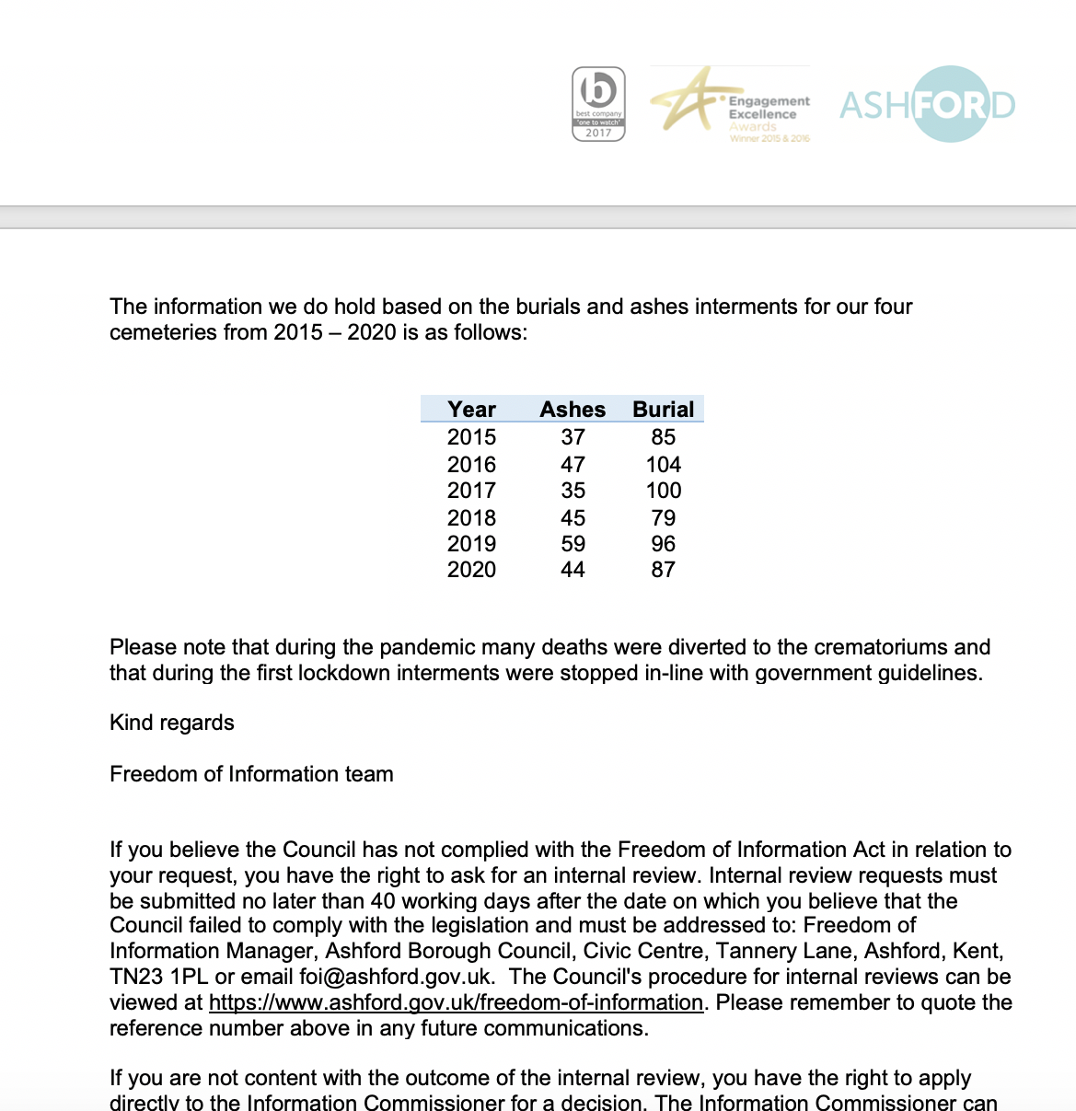

https://www.whatdotheyknow.com/request/environmental_information_regula_13#outgoing-1164962

I am writing in respect of your information access enquiry dated 28 May
2021. This request has been handled under the Freedom of Information Act
2000.
Please find below information that we hold in response to your request.
2015 166 full burials 178 ashes interments
2016 153 163
2017 120 138
2018 166 174
2019 155 158
2020 133 137
We do not hold any records for cremations, Hawkinge Crematorium, run by
Dignity have these. I attach a link to their website which includes
contact details for your assistance
The contents of this request are subject to re-use under the terms of
the [2]Open Government Licence unless otherwise specified. Publications
relying on this data must be attributed accordingly. Where released
materials are subject to 3^rd party copyright or intellectual property
rights, rights to attribution and re-use remain vested in the holder.
Personal data disclosed in conjunction with an information access request
is provided in compliance with the Council’s legal obligations. This
disclosure does not provide consent for direct marketing under the Privacy
and Electronic Communications Regulations (PECR), and should not be
construed as such.
Should you require any further information, or if you are not satisfied
with our response, please do not hesitate to contact me. You may also
request an internal review by writing to the following
address: [3][email address]
Following this, if you are not satisfied with the internal review response
you may apply to the [4]Information Commissioner for an independent review
at the following address: [5][email address]
Kind regards,
Case Management (Corporate Services)
Information Governance
Folkestone & Hythe District Council
https://www.whatdotheyknow.com/request/environmental_information_regula_17#outgoing-1164960

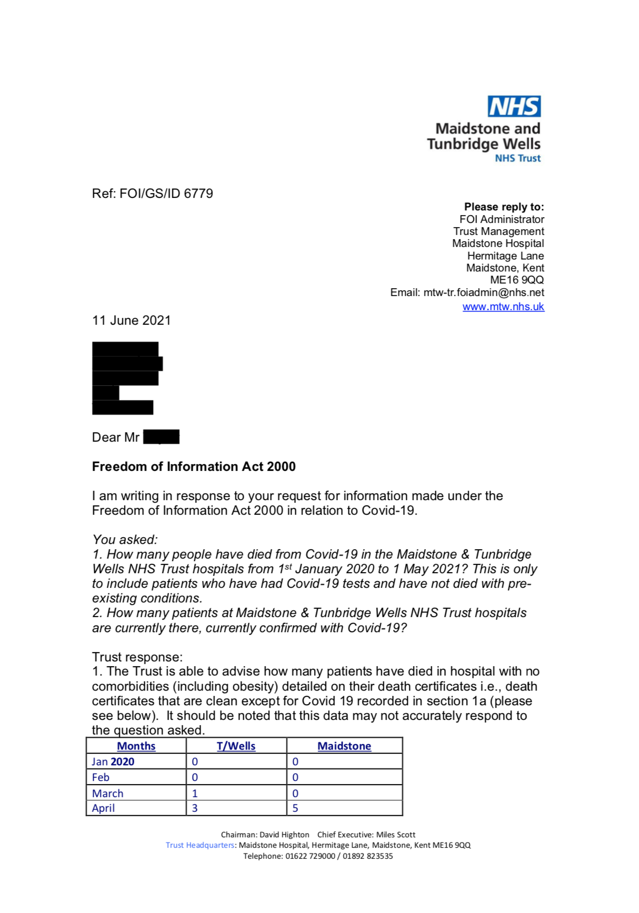
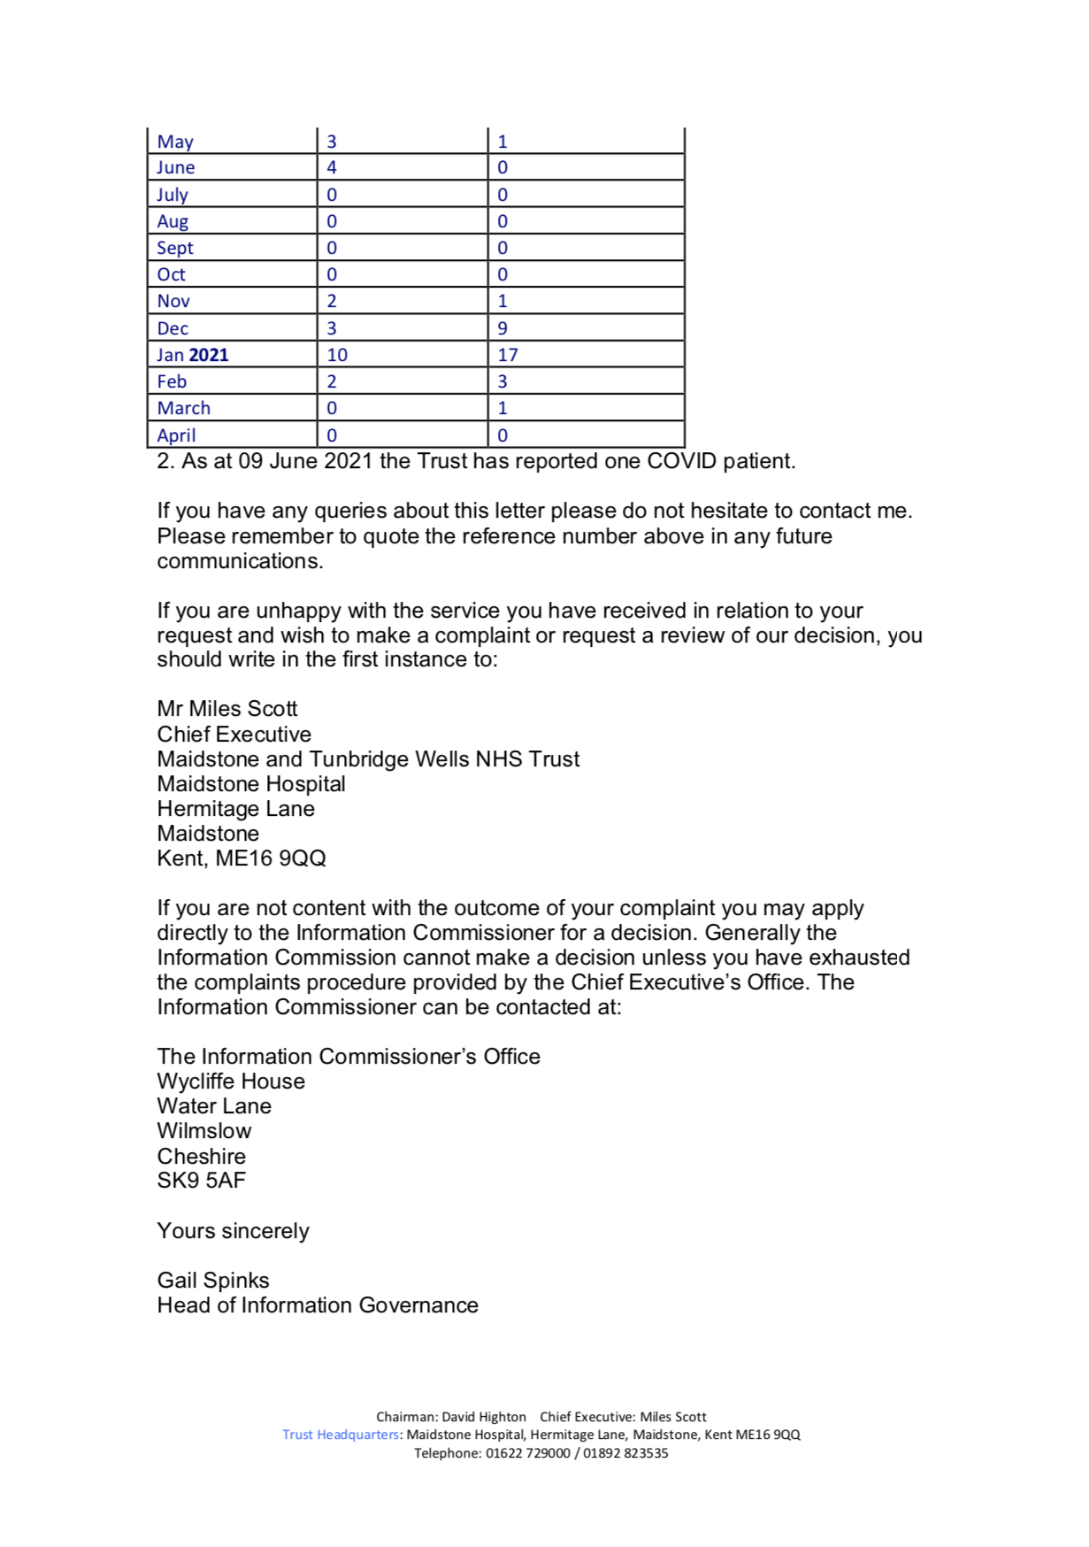

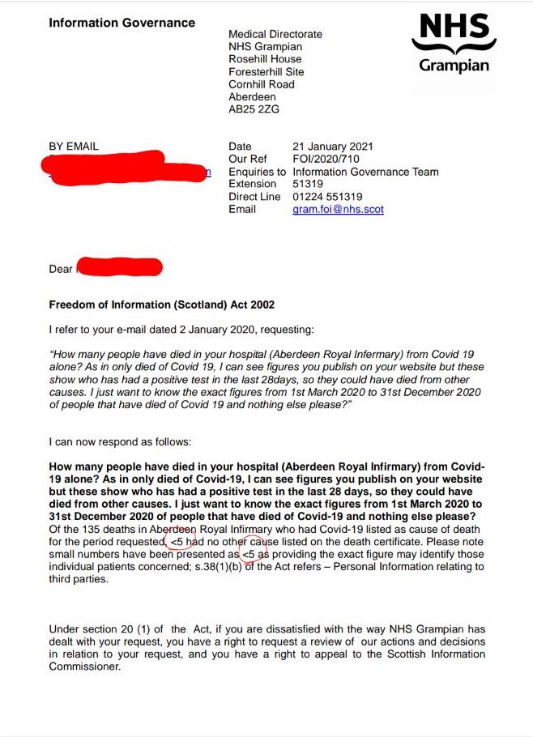

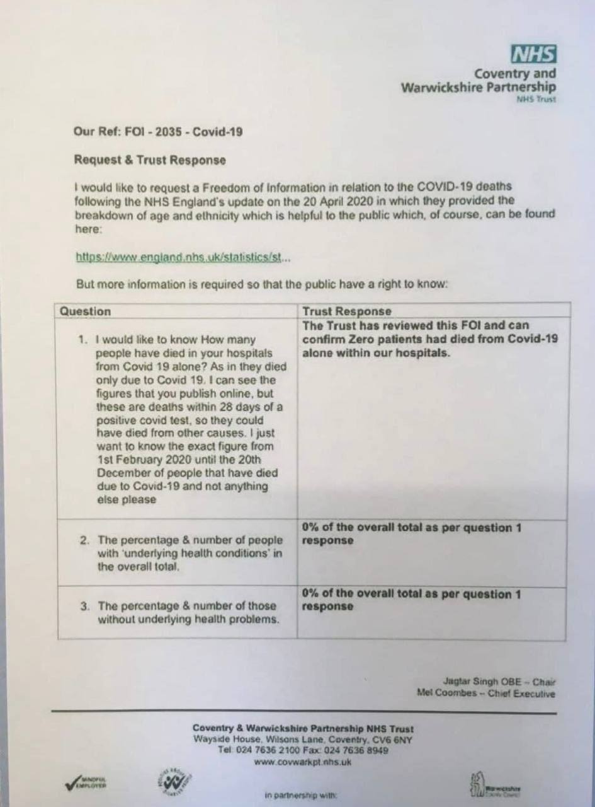

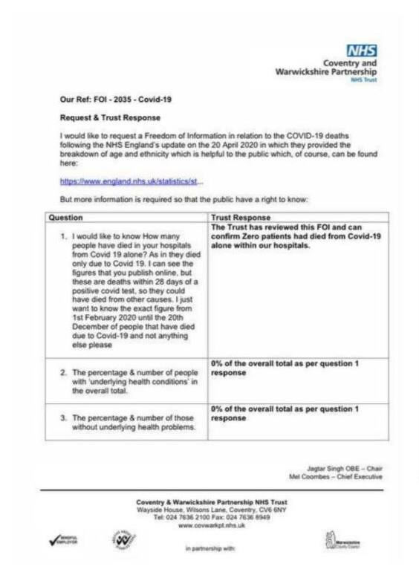

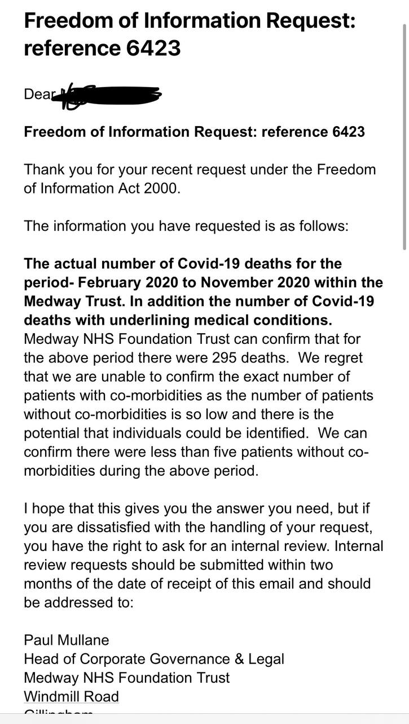

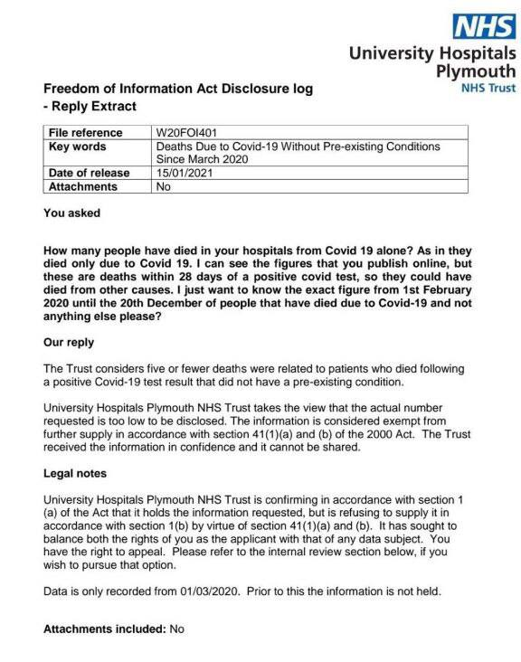

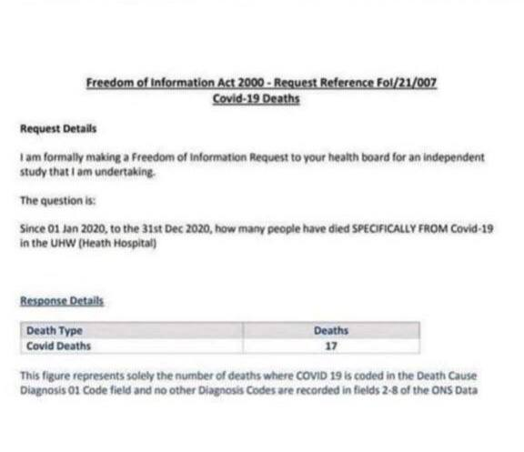

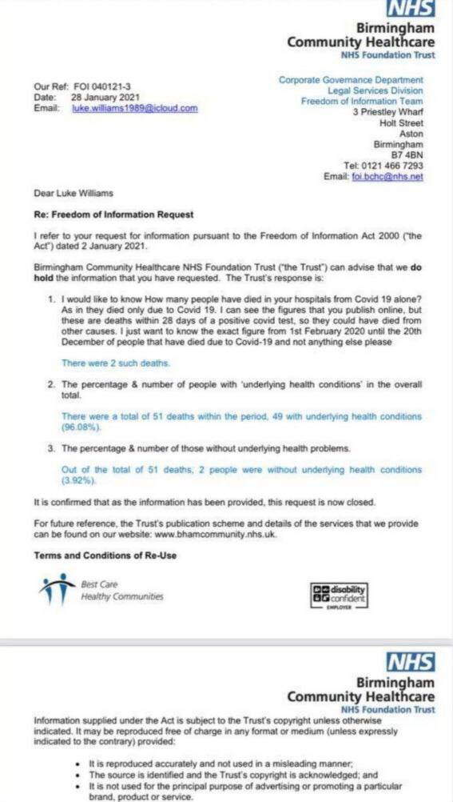

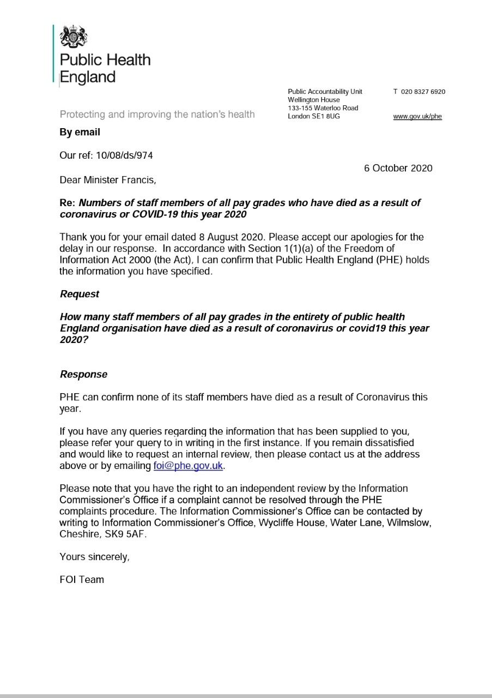

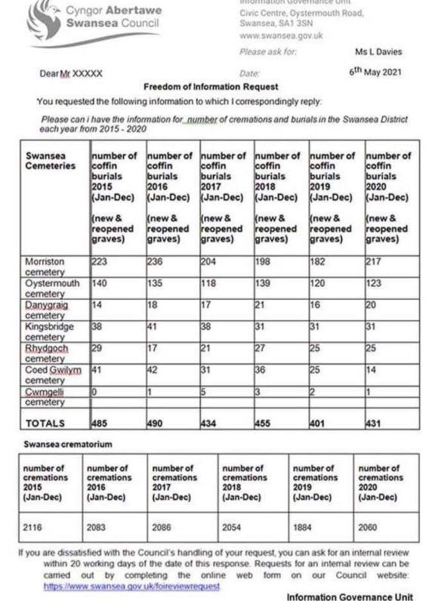

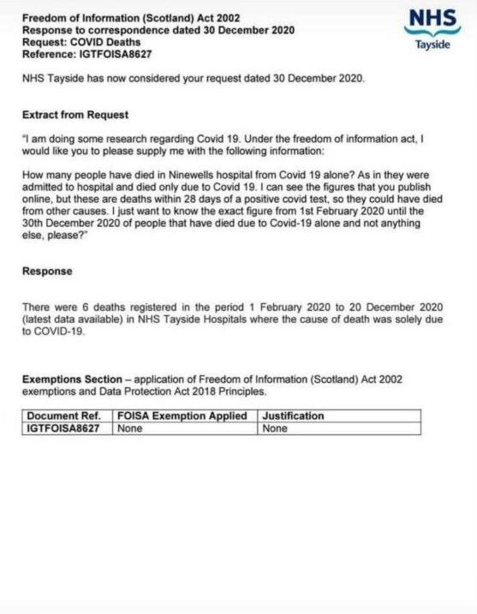

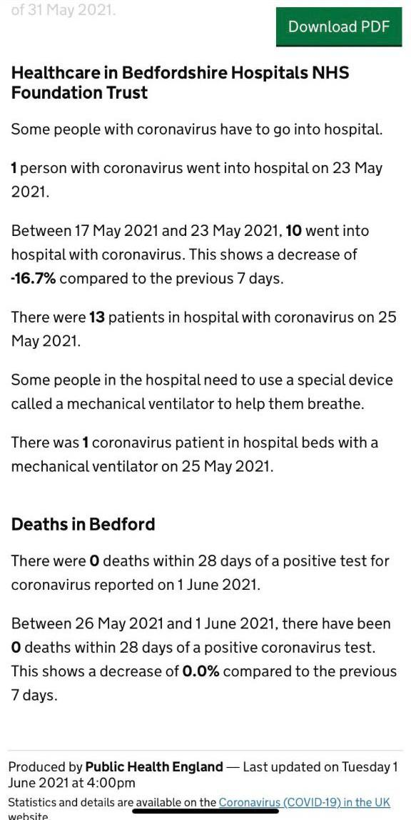

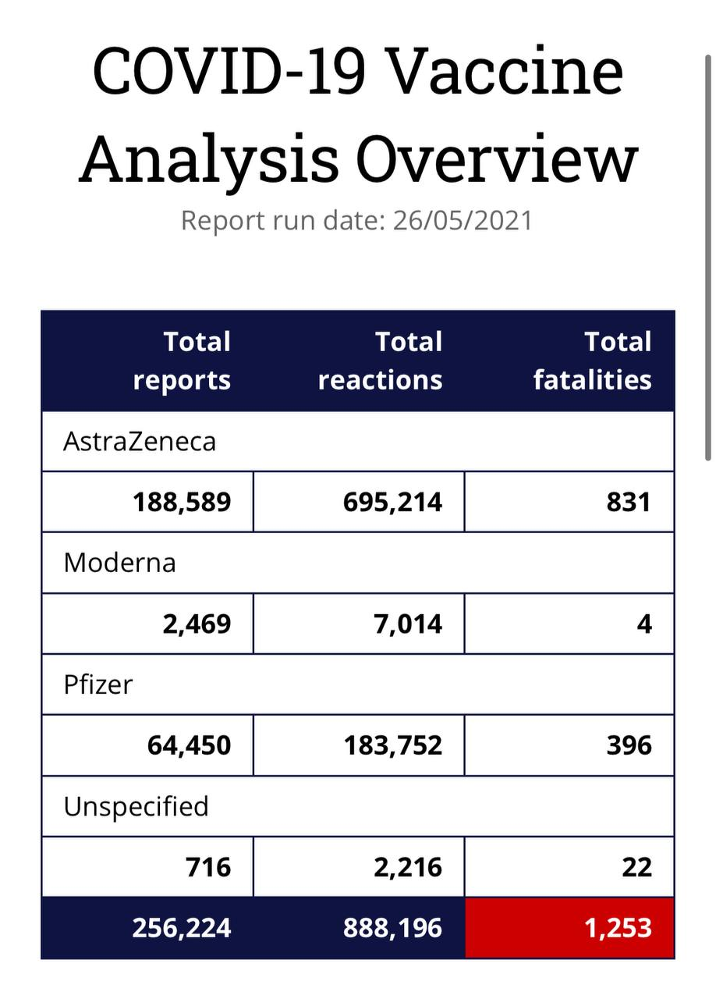

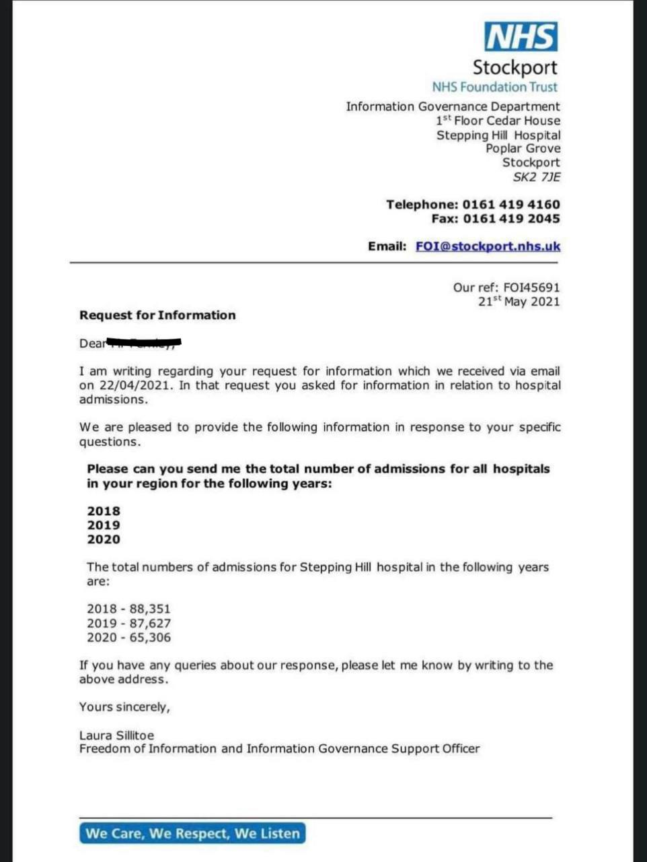

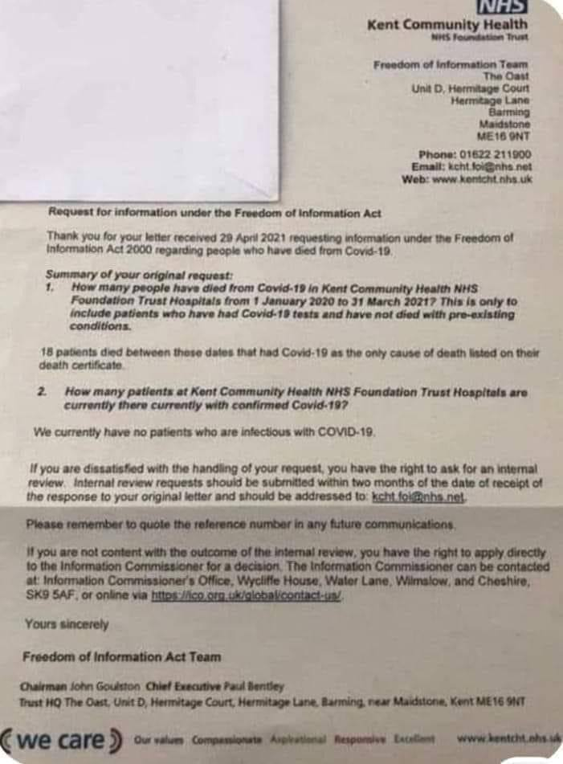

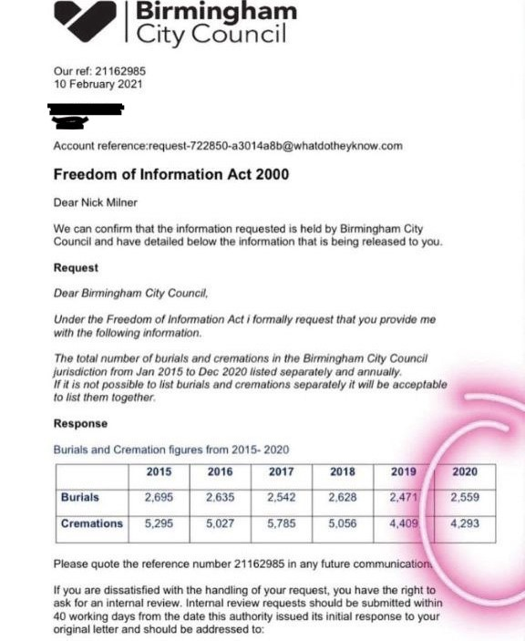

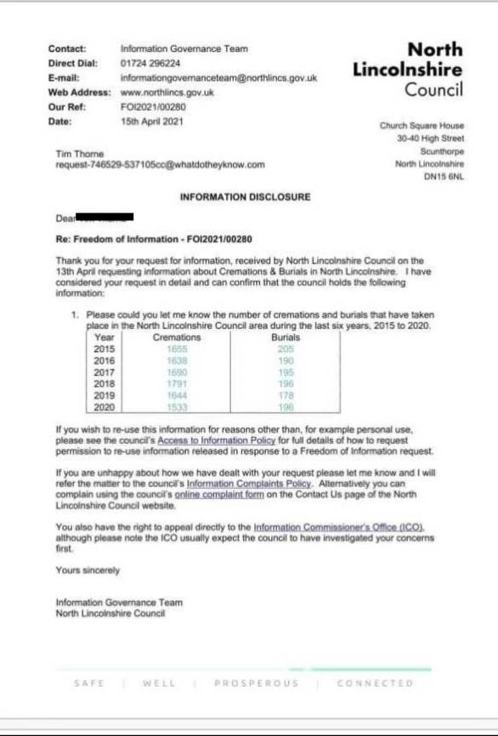

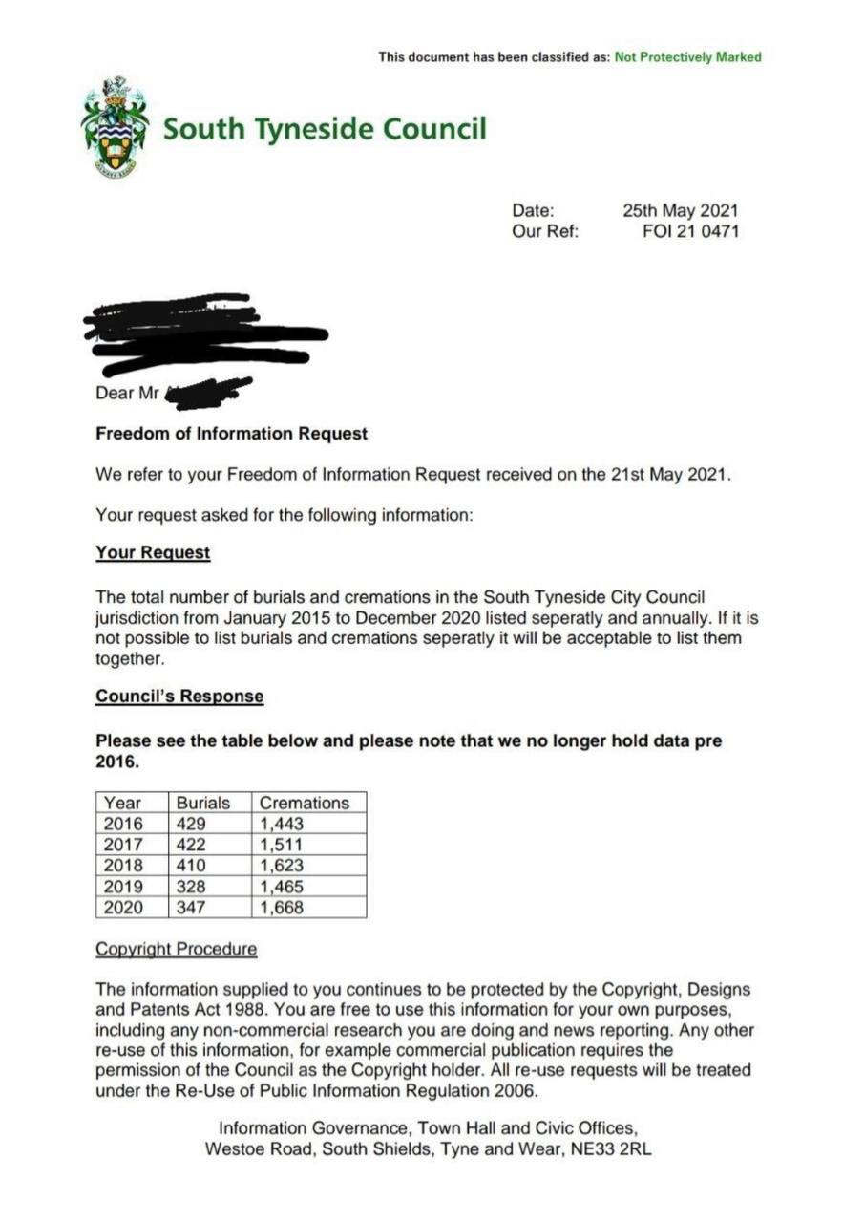

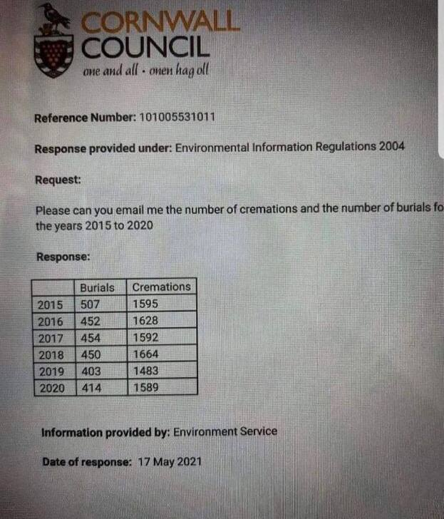

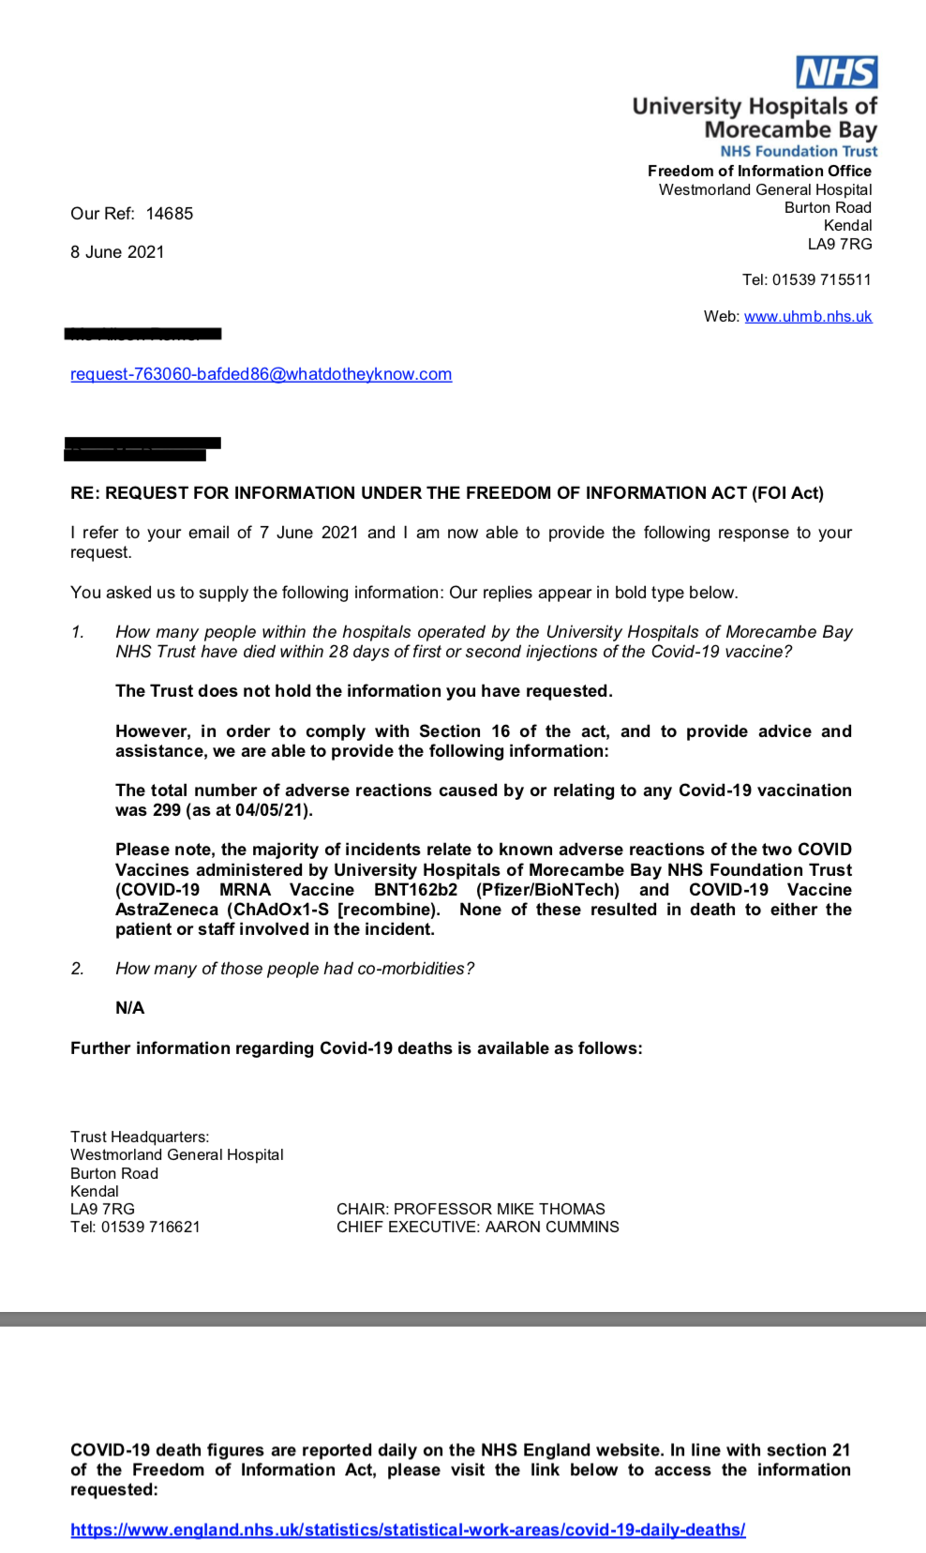

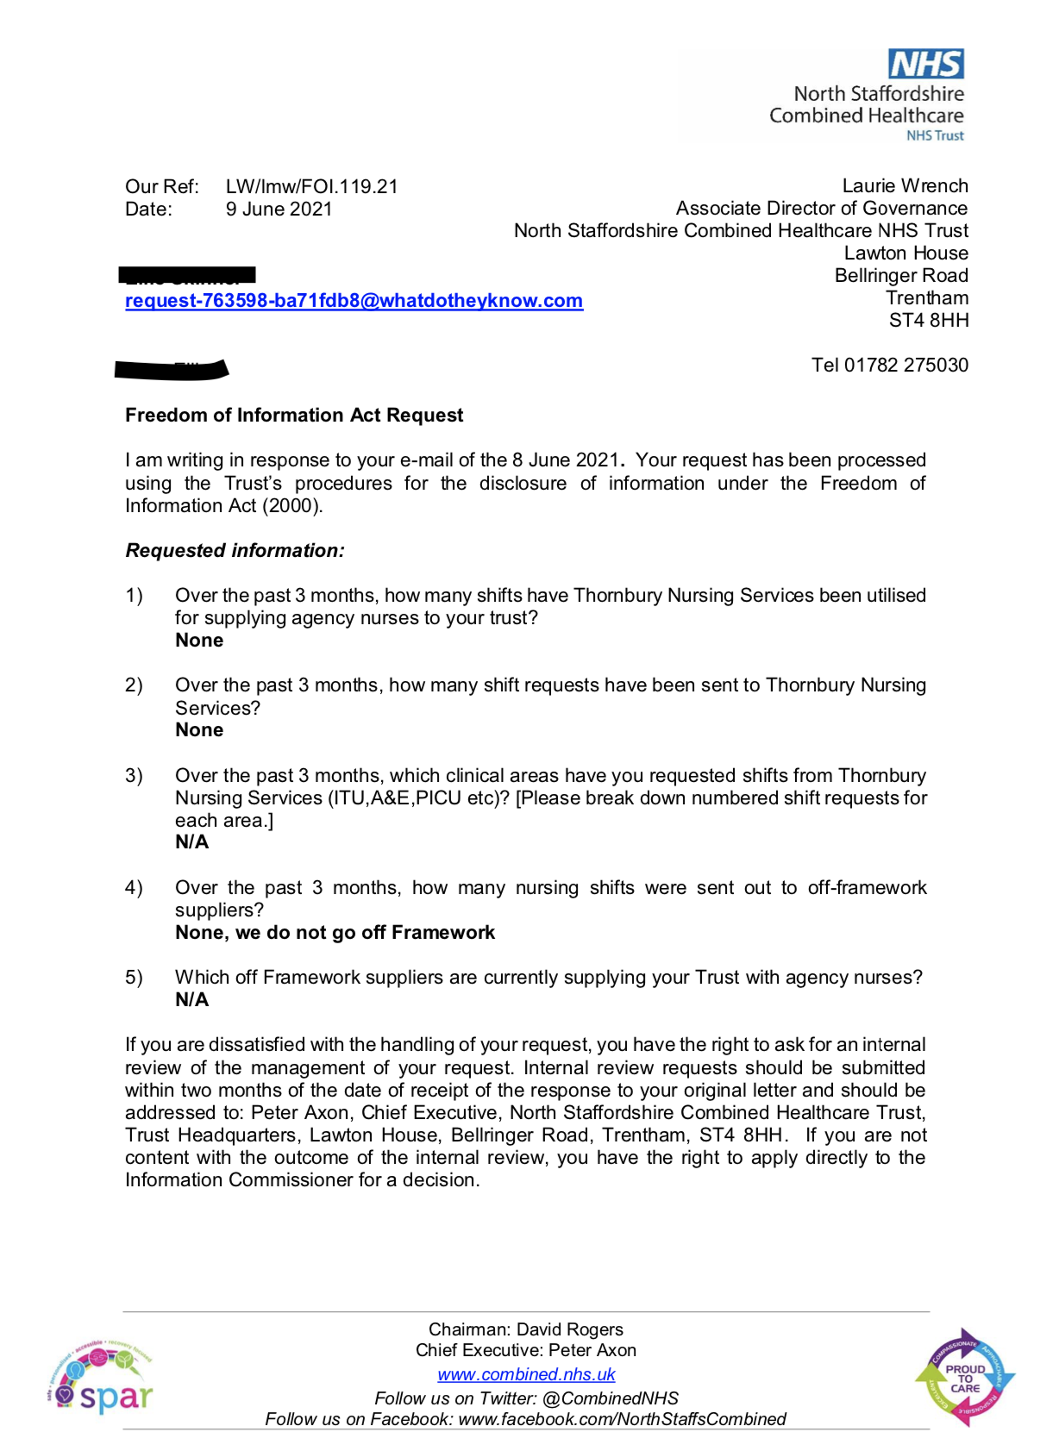

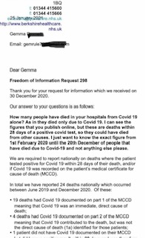

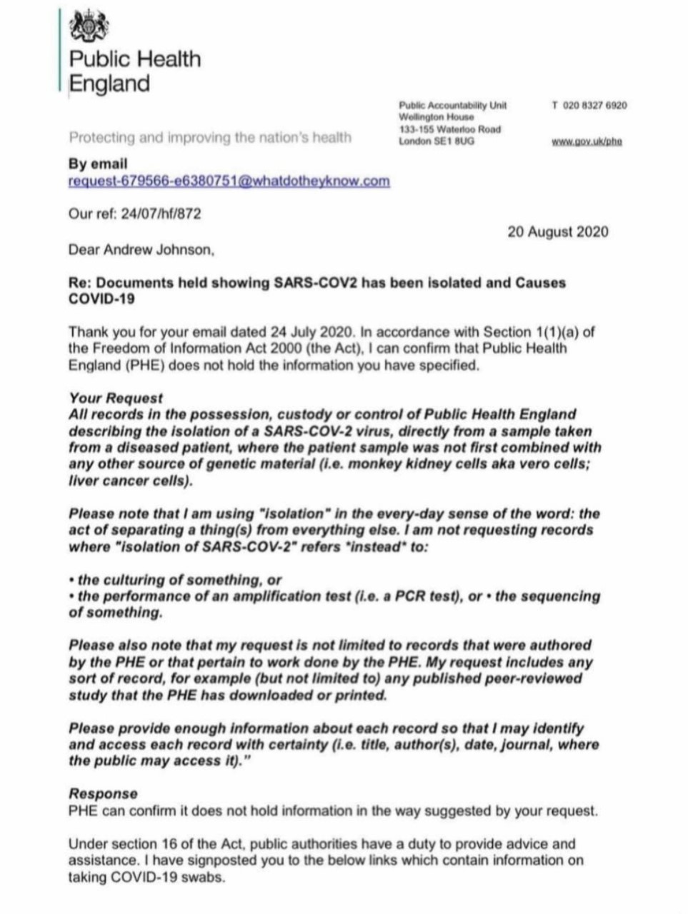

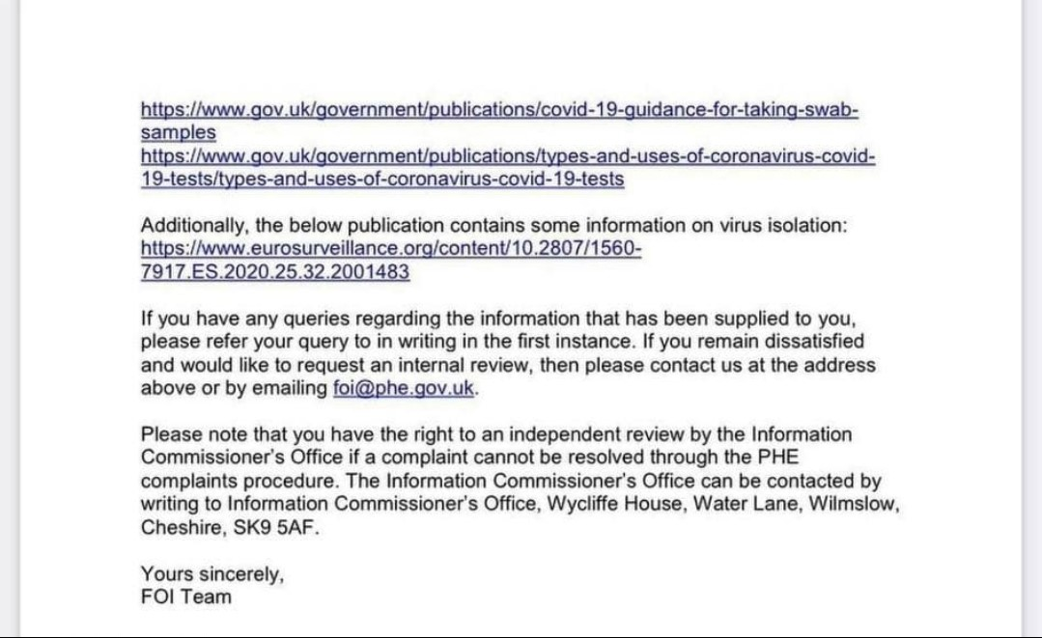

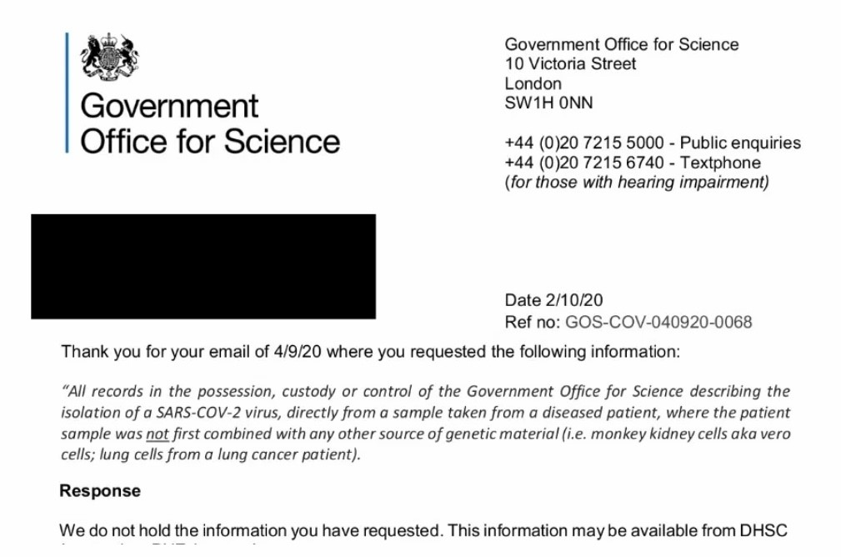

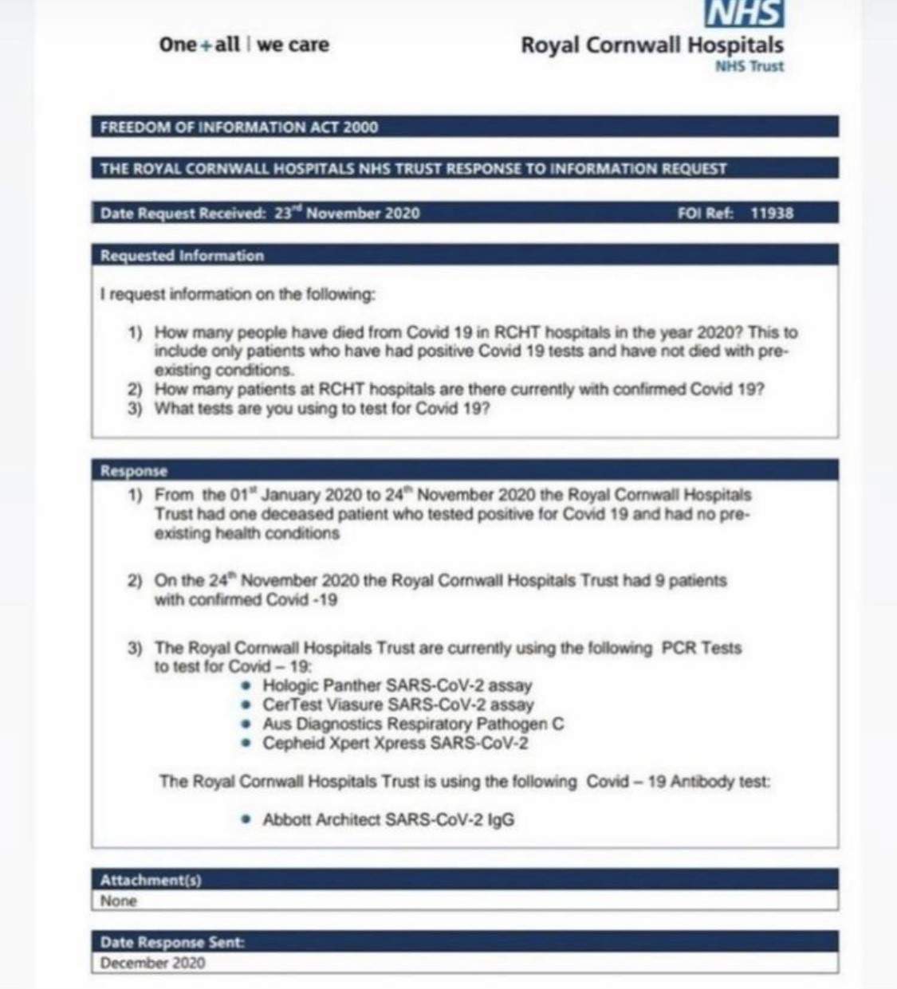

https://www.whatdotheyknow.com/request/mortality_from_sars_cov2_form_in#incoming-1808394
I am writing to confirm that the West Suffolk NHS Foundation Trust has now
completed its search for the information which you requested on 7^th May
2021
Please find our response to your request.
1. Please advise the number of patients 80+ years of age who contracted
SARS-CoV2 (Coronavirus/Covid-19) whilst an in-patient (e.g. not admitted
initially with Coronavirus but another ailment) in West Suffolk Hospital
during the period 1 November 2020 to 28 February 2021. 97
2. Please advise how many of these patients numbered in 1 above
subsequently died in hospital as a result of contracting the Coronavirus.
Of these 97 patients there were 30 patients who passed away in hospital,
however it cannot be confirmed that the death was only caused due to
coronavirus.
3. Please advise how many of the deaths in No. 1 above were reported to
the Coroner 4
4. Please advise how many of the deaths in No. 1 above were purely from
Coronavirus alone with no other comorbidity, by checking the medical
records. Unable to determine if coronavirus was the only cause of death as
this is recorded on the death certificate. However of the 30 patients who
passed away in question 2, there were only 2 patients with no long term
conditions recorded.
5. If no. 4 exceeds the £450 charge under Section 12 of the FOI, please
reduce the time scale to 1 December-31 December 2020.
6. Please advise what additional procedures have been put in place for
infection control following the 3 outbreaks of Coronavirus in separate
wards of the WSH during December 2020.
Roll out of the Covid curtains programme to reduce the risk of patient to
patient exposure.
Increase screening frequency of Covid contacts to every 72 hours during
outbreaks to detect new cases as early as possible.
Review of Housekeeping services in the Community in-patient areas.
Promotion of the appropriate use of PPE by the introduction of PPE
champions in the clinical areas.

Increased frequency of environmental and PPE audits
The information supplied to you continues to be protected by the
Copyright, Designs and Patents Act 1988. You are free to use it for your
own purposes, including any non-commercial research and for the purposes
of news reporting. Any other reuse, for example commercial publication,
would require the permission of the copyright holder.

If you are unhappy with the service you have received in relation to your
request and wish to make a complaint or request a review of our decision,
you should write to:

Chief Executive
West Suffolk NHS Foundation Trust
Hardwick Lane
Bury St Edmunds
Suffolk IP33 2QZ

FOI REFERENCE NUMBER: 2601
Thank you for your email of 15^th April 2021 requesting information Under
the Freedom of Information Act (FOIA) 2000. I set out below your request
together with our response:

Dear Croydon Health Services NHS Trust,

1) How many in-patient bed spaces were there in the hospital on 1
April 2020 and on 1 April 2021?

2) How many in-patient bed spaces were occupied on 1 April 2020 and
on 1 April 2021? For each date, please split the figure between NHS
patients and private patients.

Date Bed Spaces available Beds Occupied
01/04/2020 422 374
01/04/2021 428 399

Both figures are for ‘general and acute’ beds as per KH03 definition (i.e.
this does not include critical care beds, maternity beds, and beds for
‘well babies’).
These are all NHS beds; we do not have private beds.

The information supplied to you continues to be protected by the
Copyright, Designs and Patents Act 1988. You are free to use it for your
own purposes, including any non-commercial research that you are doing and
for the purposes of news reporting. Any other reuse, for example
commercial publication, would require the permission of the copyright
holder which must be expressly given.

If you are unhappy with this response the Trust has a formal Complaints
Procedure which you may use by writing to The Medical Director,
[1][Croydon Health Services NHS Trust request email]. If you remain unsatisfied you may contact the
Information Commissioner’s Office at Wycliffe House, Water Lane, Wilmslow,
Cheshire SK9 5AF. Further details of this procedure can be found
online at - [2]https://ico.org.uk/.
Thank you for your interest in Croydon Health Services NHS Trust.

Yours sincerely

FOI Team
Croydon Health Services NHS Trust
https://www.whatdotheyknow.com/request/number_of_nhs_and_private_in_pat_3#incoming-1801367

[FOI #710636 email]
Further to your email of 14 May 2021, please find attached an updated
table in respect of question 1 of your original FOI request. As
requested, this table has been updated to include the December 2020 data.
Please note that some of the original figures have also been updated
following some data validation work.

Month of Death | LRI | Glenfield | LGH | All
Jan 20 | 0 | 0 | 0 | 0
Feb 20 | 0 | 0 | 0 | 0
Mar 20 | 31 | 6 | 0 | 37
Apr 20 | 144 | 57 | 7 | 208
May 20 | 96 | 16 | 8 | 120
Jun 20 | 28 | 13 | 4 | 45
Jul 20 | 18 | 6 | 2 | 26
Aug 20 | 4 | 1 | 0 | 5
Sep 20 | 5 | 3 | 1 | 9
Oct 20 | 18 | 14 | 0 | 32
Nov 20 | 109 | 31 | 0 | 140
Dec 20 | 120 | 72 | 10 | 202
ALL | 573 | 219 | 32 | 824

Yours sincerely

Kate Rayns
Corporate and Committee Services Officer
University Hospitals of Leicester NHS Trust
https://www.whatdotheyknow.com/request/covid_deaths_per_month_3#incoming-1800192

The number of deaths registered in South Lanarkshire from 2016 to 2020 are as follows:-

Year | 2016 | 2017 | 2018 | 2019 | 2020
Totals | 3550 | 3281 | 3561 | 3359 | 4073

As a death which occurs in Scotland can be registered with any local authority in Scotland the figures above are deaths registered in South Lanarkshire. The link I provided in my previous email related to the number of deaths by council area in Scotland which includes deaths registered in other local authority areas.
I hope this information is sufficient for your purposes.
Regards
Carol
Carol McKee
Licensing and Registration Co-ordinator
(Litigation, Licensing and Registration Section)
Finance and Corporate Resources
Administration and Legal Services
South Lanarkshire Council
Floor 11, Council Offices, Almada Street,
Hamilton ML3 0AA
Phone: (01698) 454800
Fax: (01698) 454810
Email: [email address]
Council website: www.southlanarkshire.gov.uk
Click link to see our most recent annual report
NHS Inform - Covid-19
https://www.whatdotheyknow.com/request/deaths_in_last_5_years_27#incoming-1799451

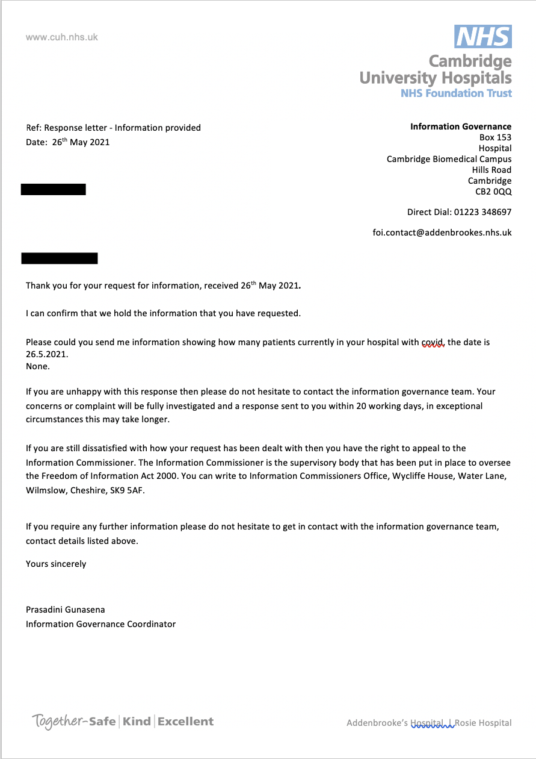
https://www.whatdotheyknow.com/request/how_many_covid_patients_do_you_h#incoming-1798896

